1. **Write a Java Program to reverse a string without using String inbuilt function reverse ().**

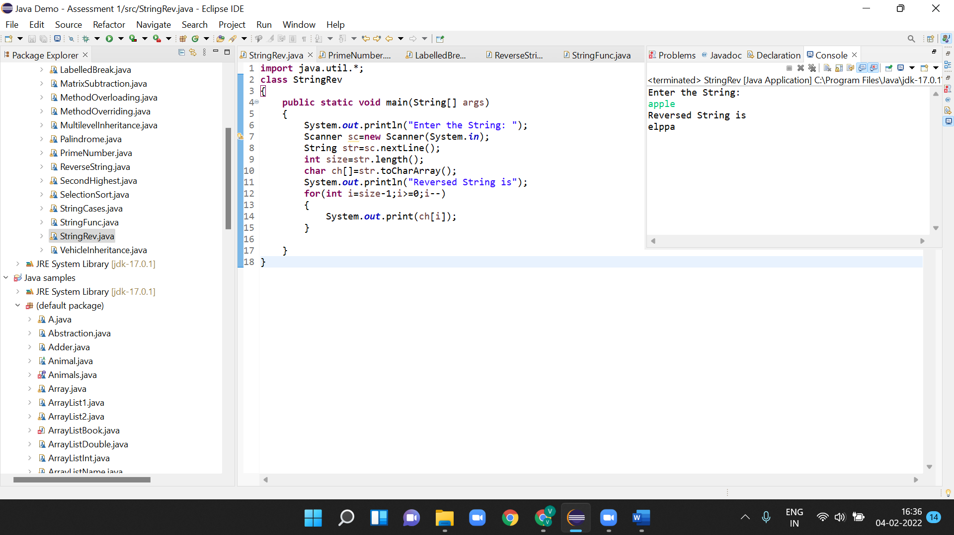

1. **Write a program to take an input number from the programmer and calculate all the prime numbers from 0 to that number. Store all the prime numbers in an array and display the array elements.**

**Example: Input=10**

**Output:**

**1,2,3,5,7**

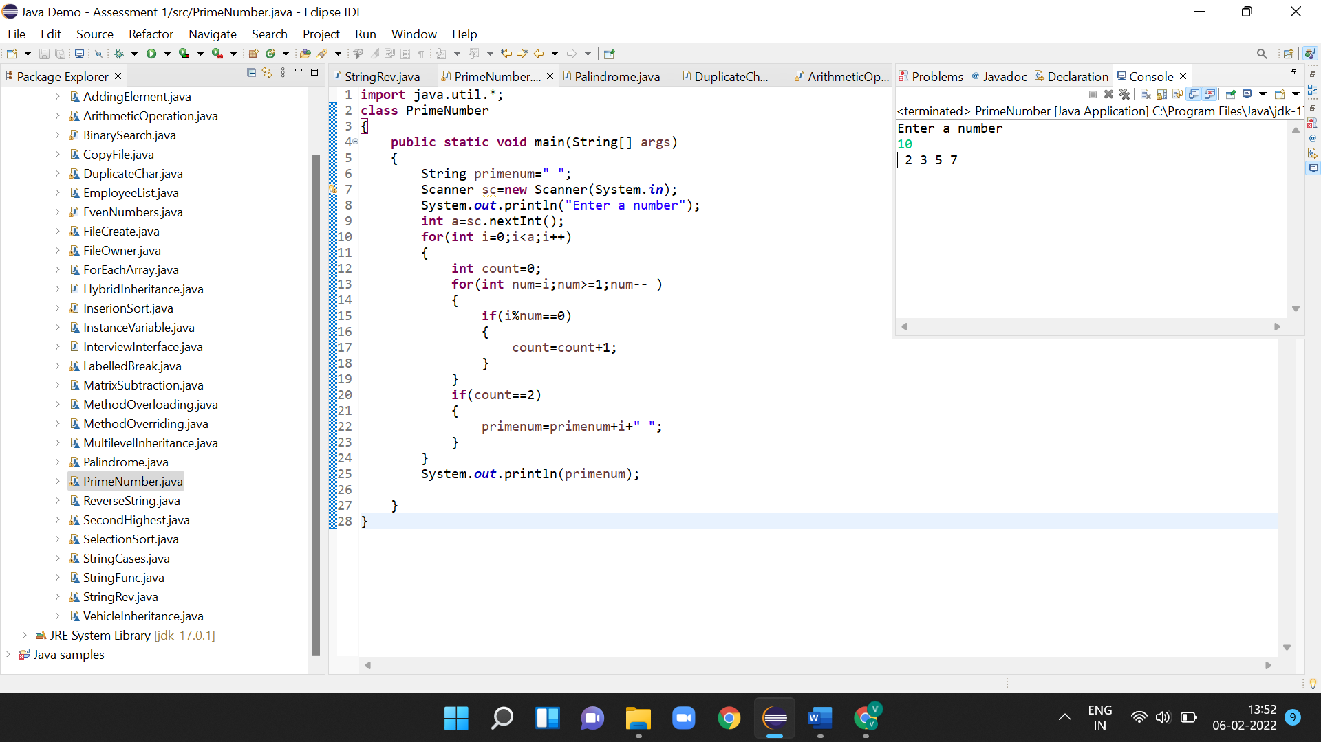

1. **Write a Java Program to find whether a string or number is palindrome or not.** 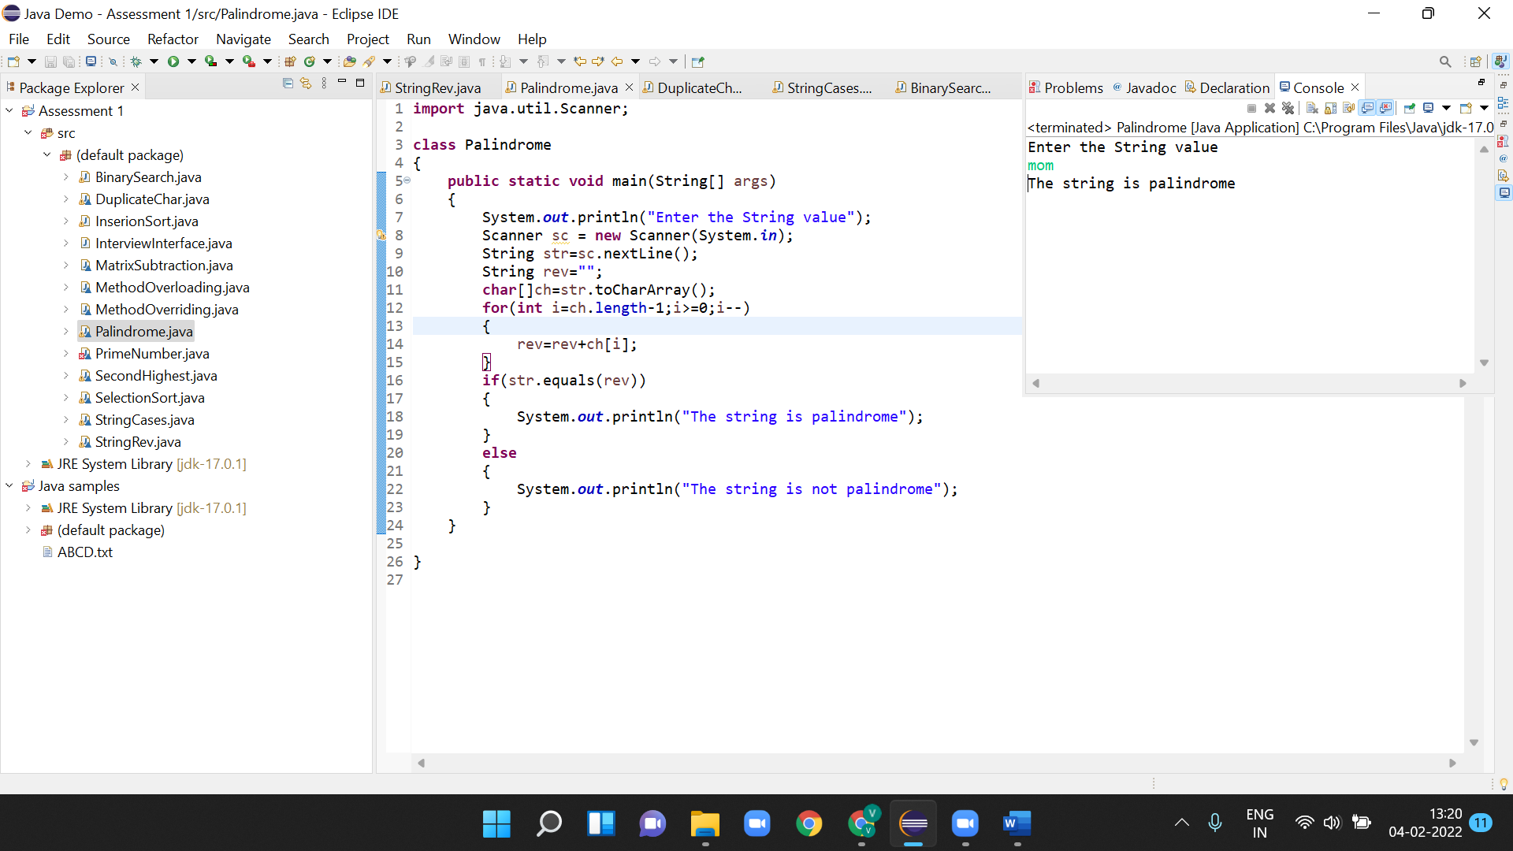

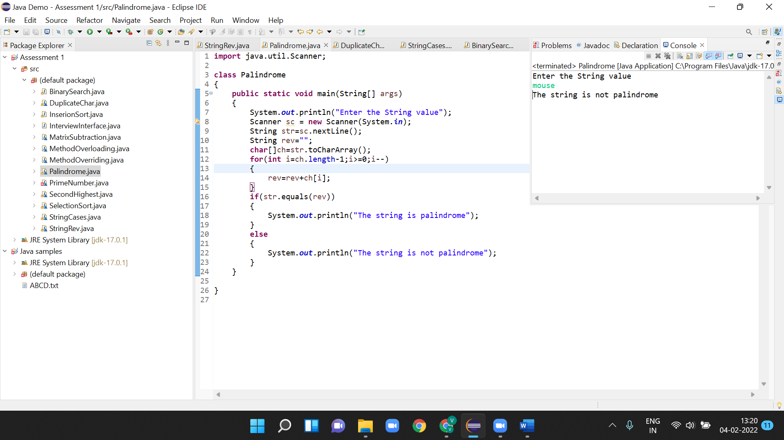

**4.Write a Java Program to find the duplicate characters in a string**

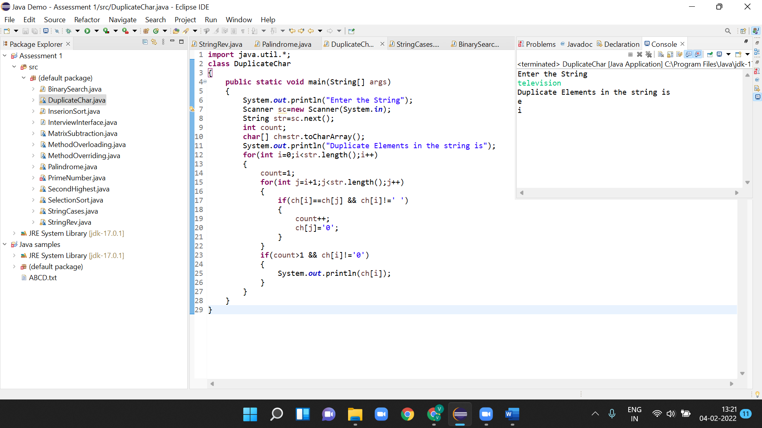

**5.Write a Java Program to find the second-highest number in an array**

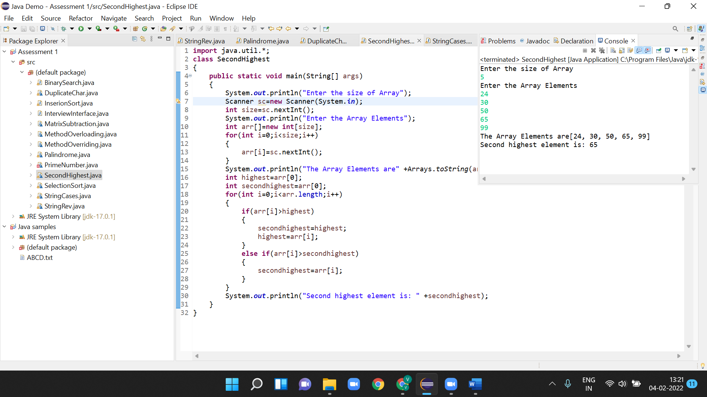

**6.Write a java program to subtract two matrices. Take the input of the matrices from the user.**

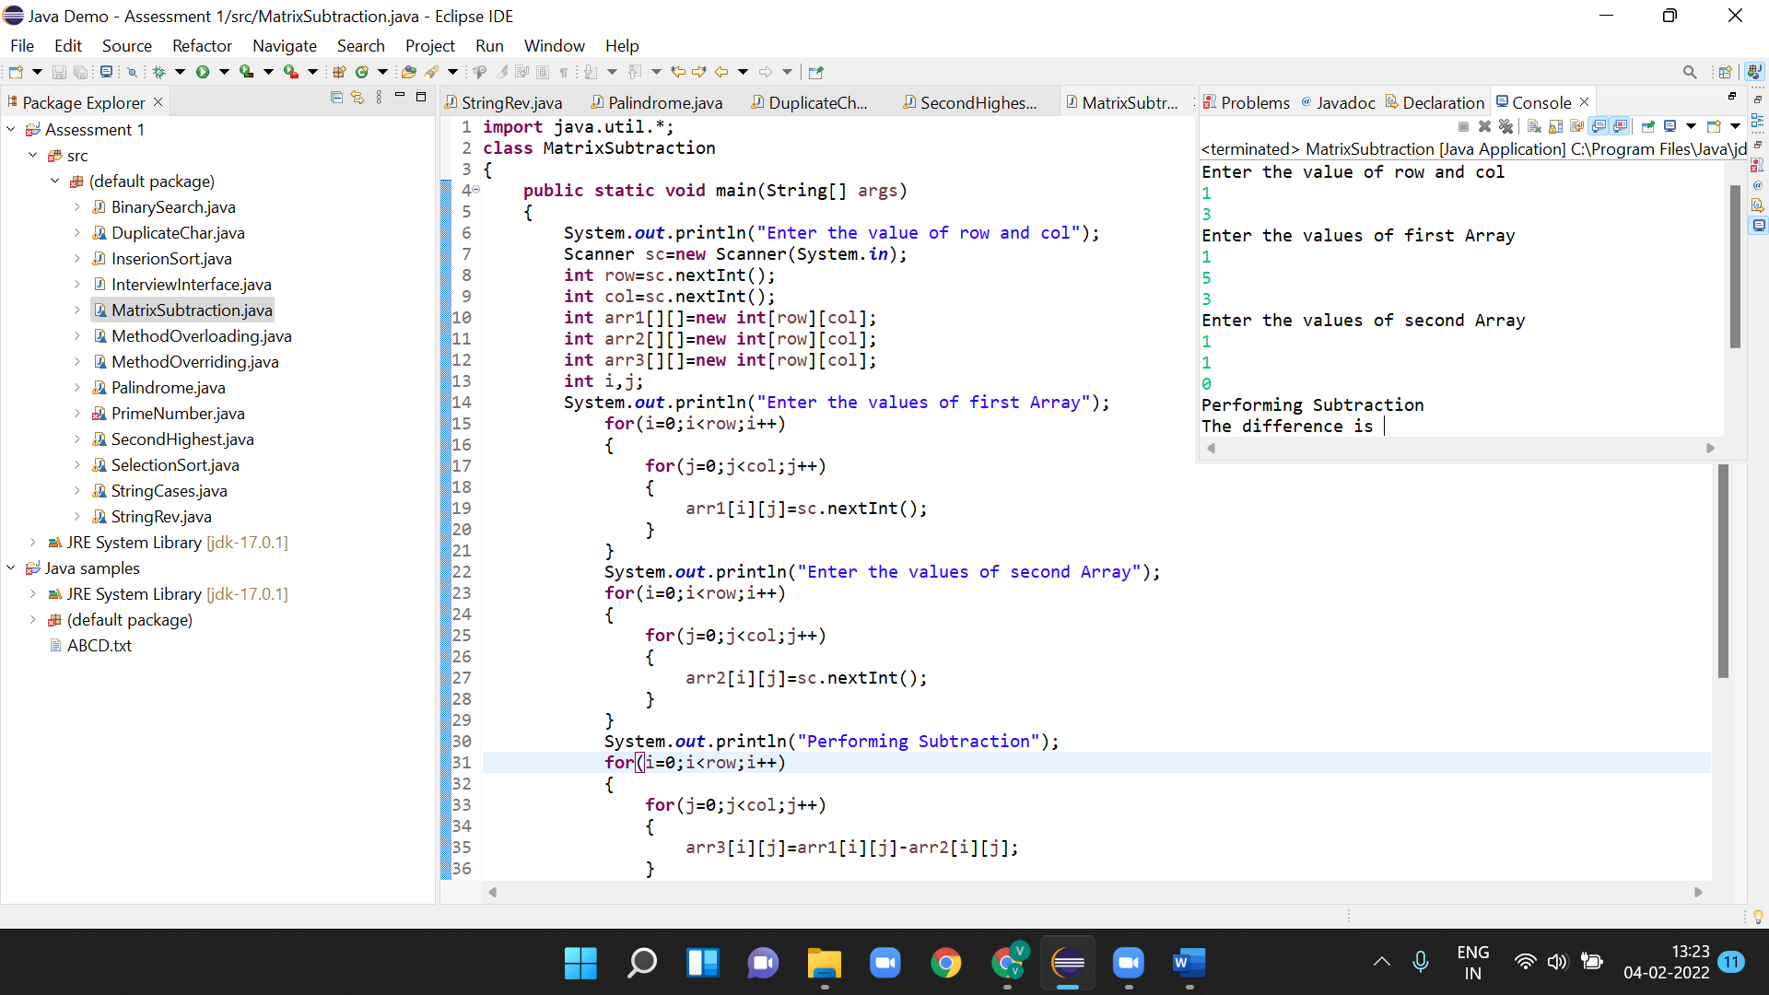

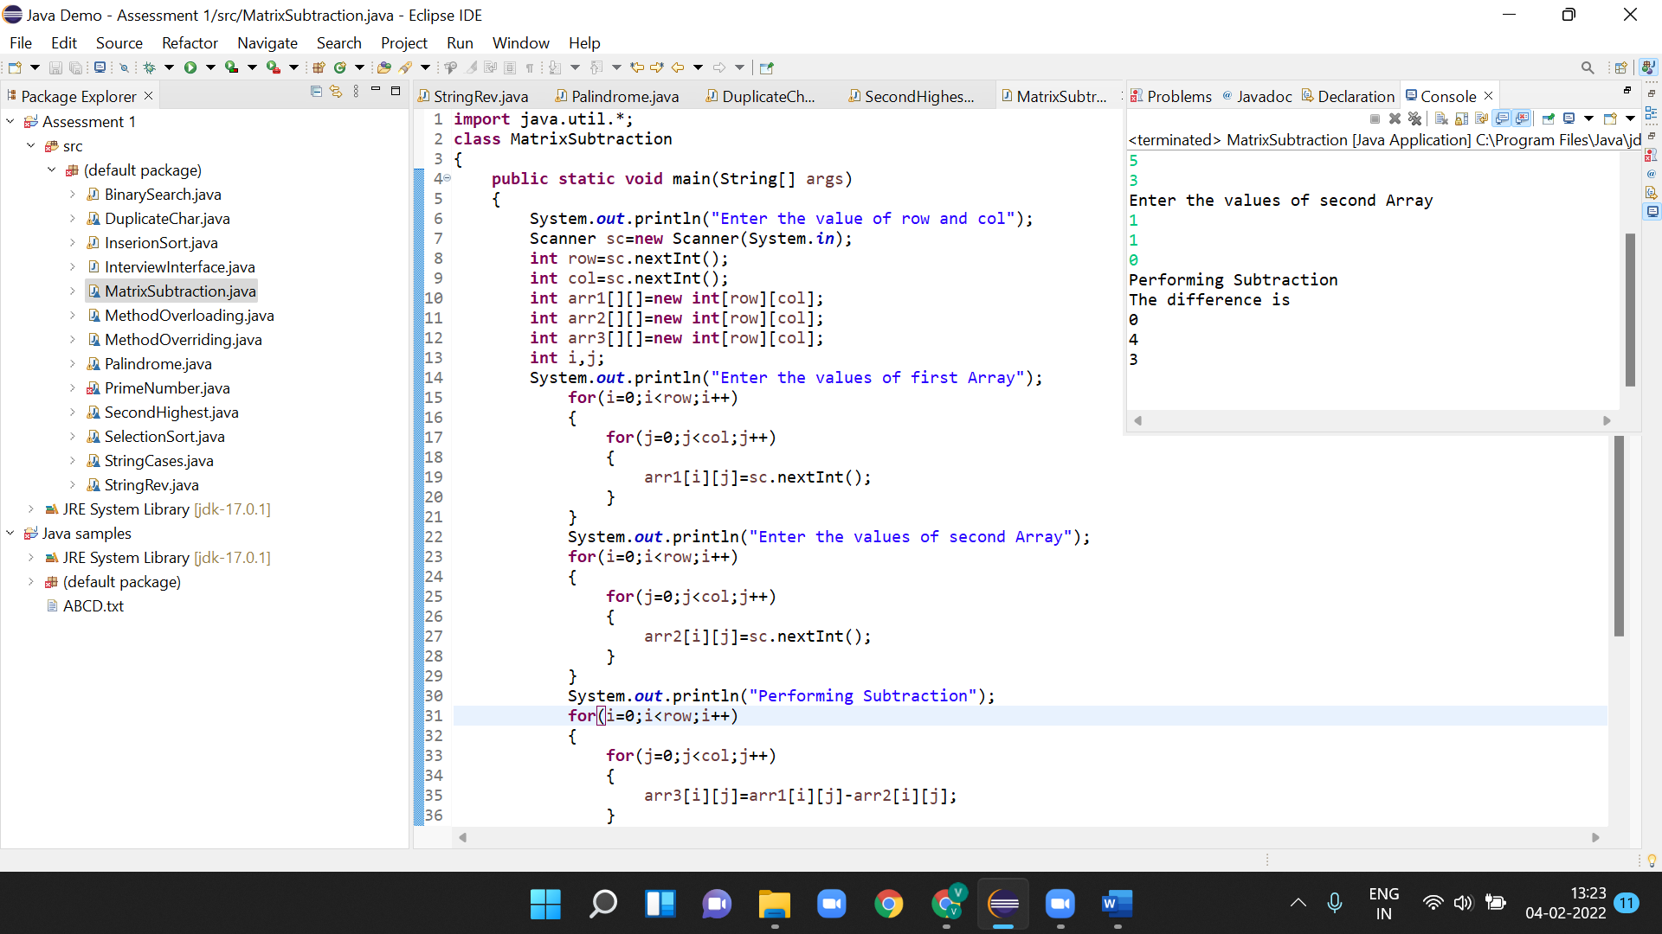

**7.Write a java program to take a string input from the user. Convert all the uppercase letters to lowercase and vice-versa.**

**Example:**

**Input:**

**MIcroSoft**

**Output:**

**miCROsOFT**

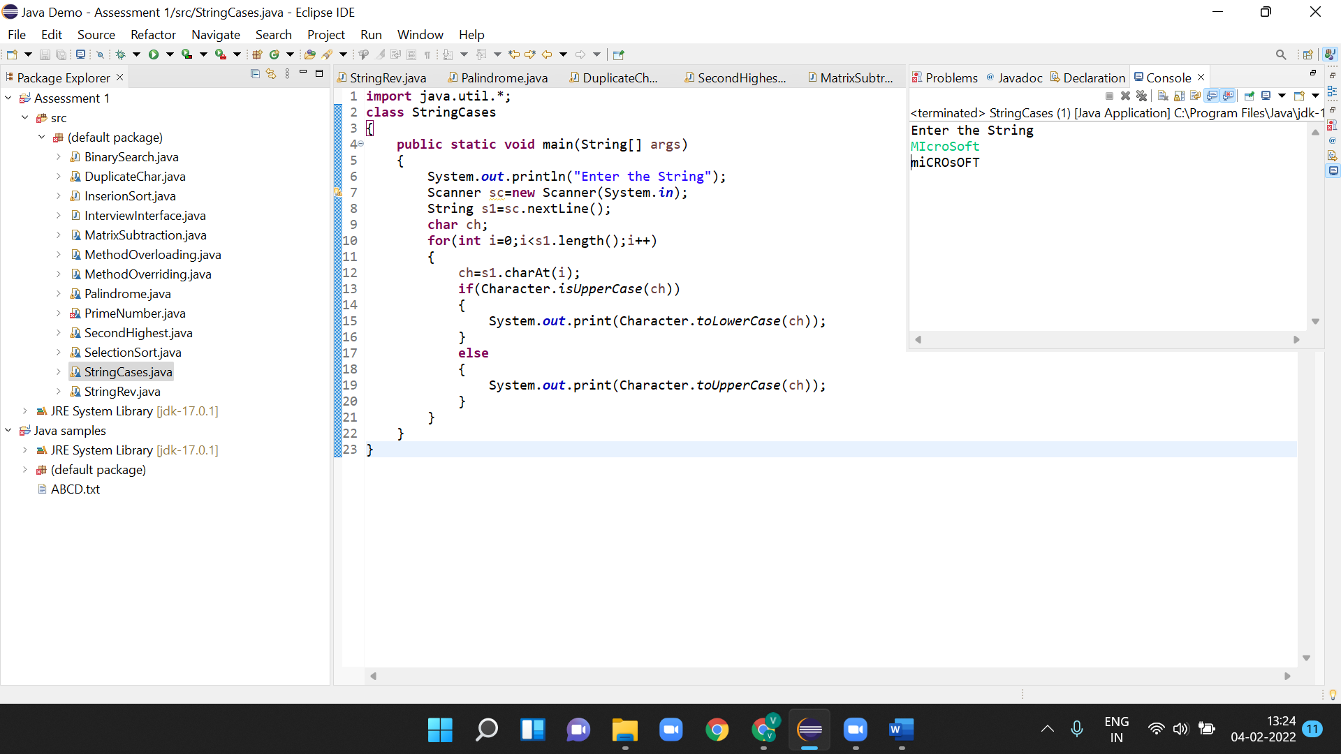

**8. Write a java program to take an input array of integers and sort the array using insertion sort**

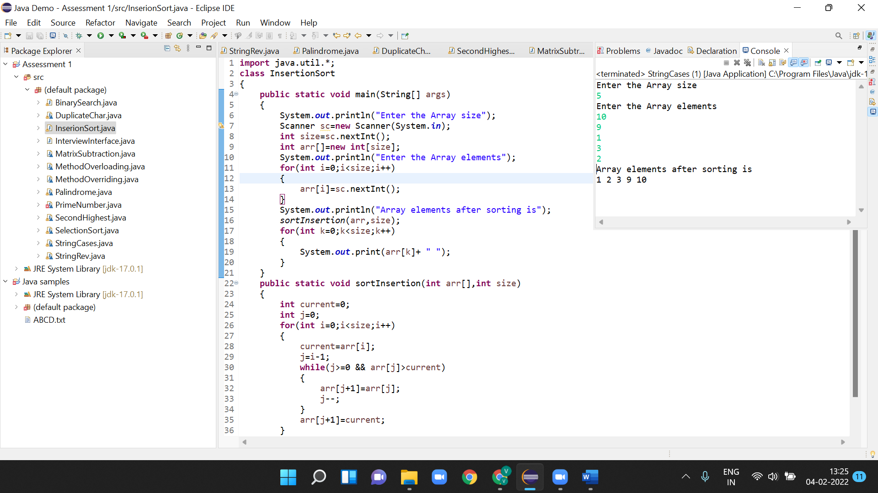

1. **Write a java program to take an input array of integers and search for a particular number given by the user. Use binary search algorithm.**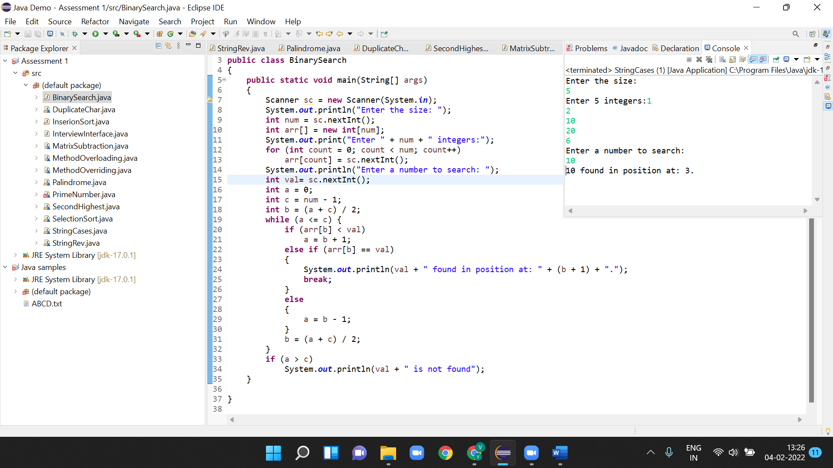
2. **Write a java program to take an input array of integers and sort the elements in a descending order using selection sort.**

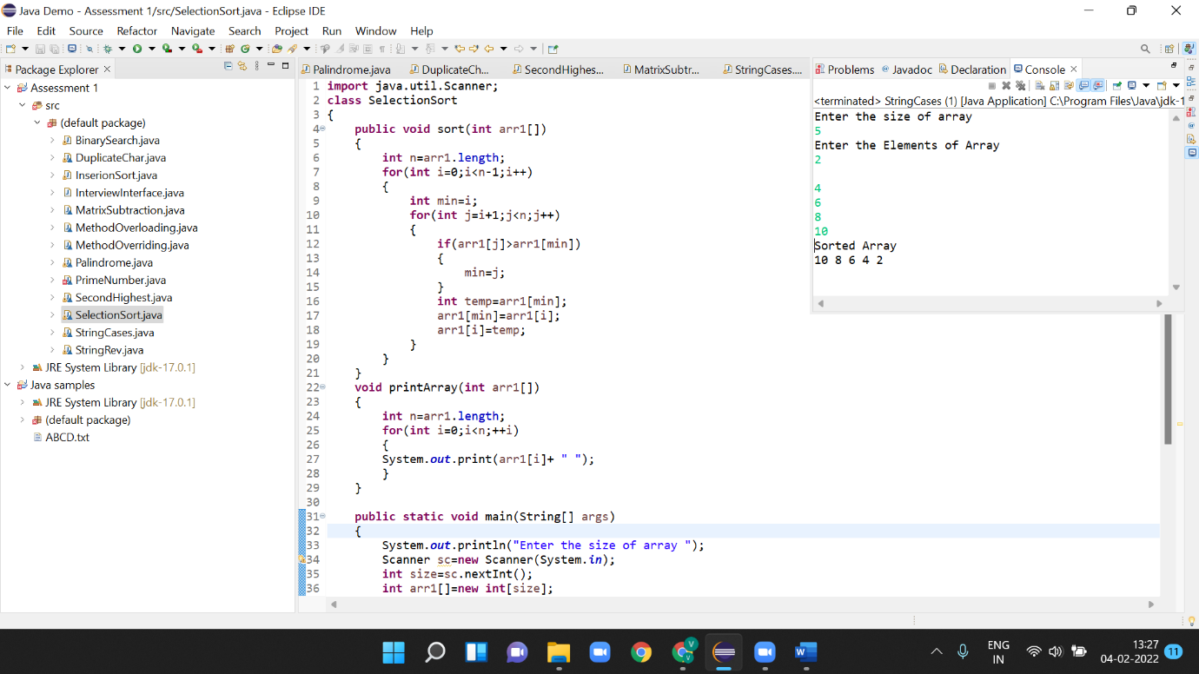

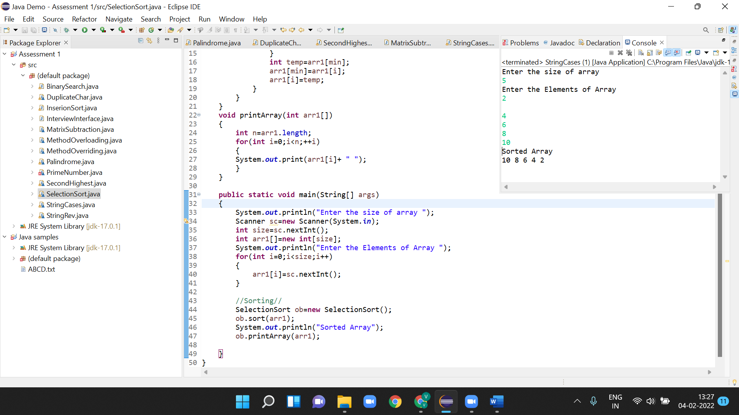

1. **Write a java program to achieve 100% abstraction.**

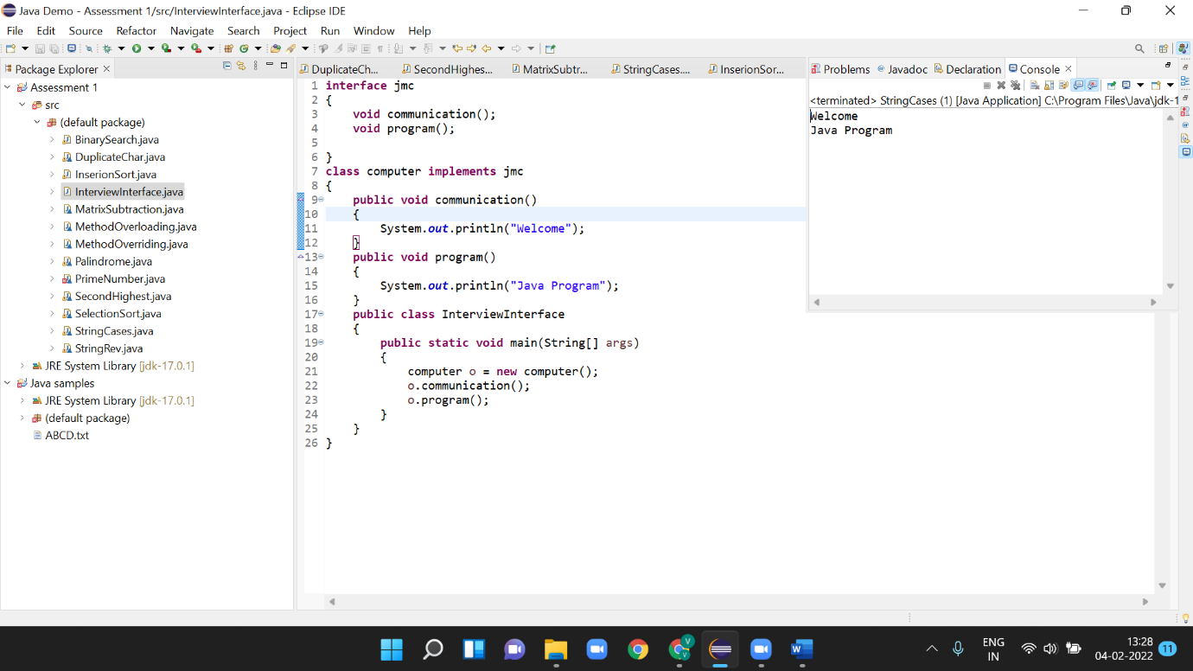

**12.Write a java program to implement method overloading**

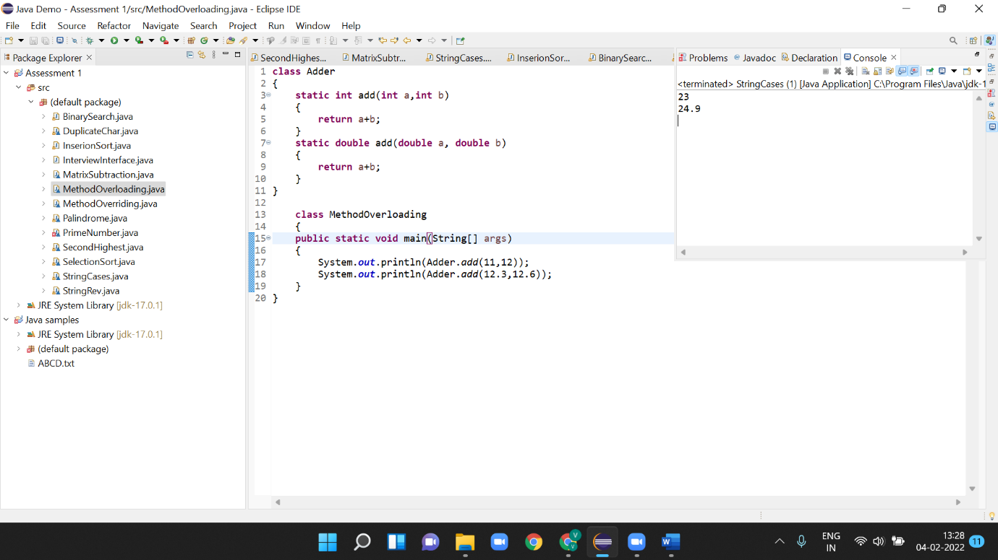

**13.Write a java program to implement method overriding**

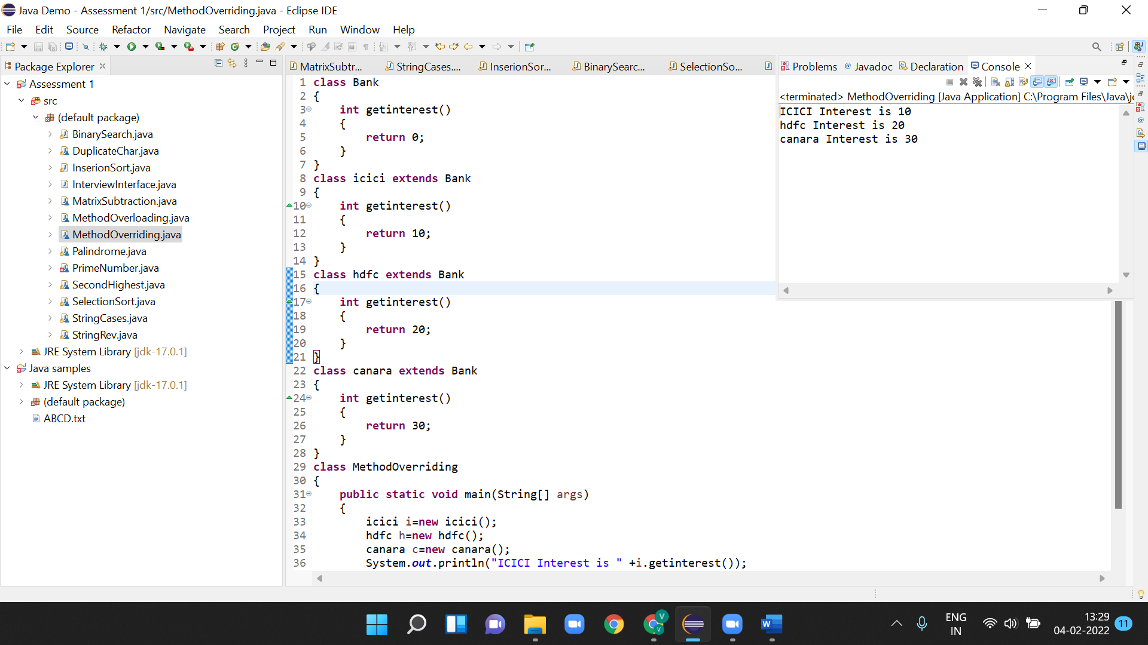

**14.Write a java program to implement Hybrid Inheritance.**

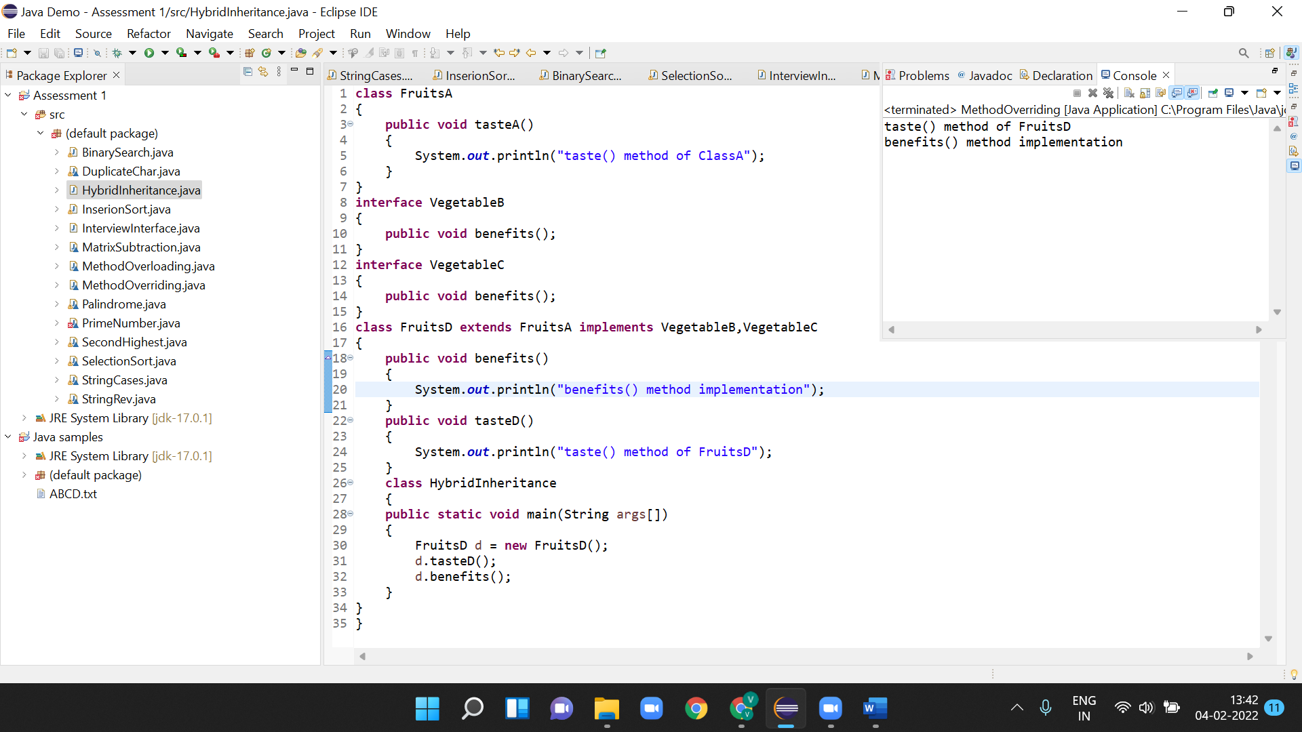

**15.Write a java program to implement multilevel inheritance**

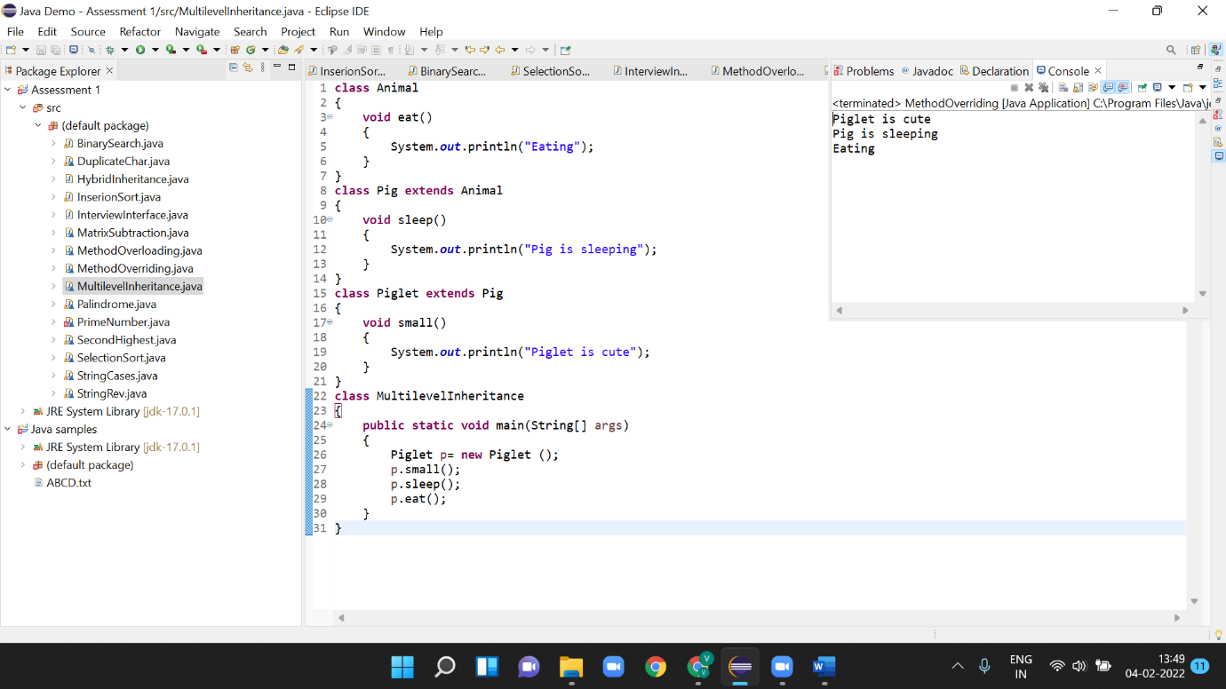

**16.Write a java program to take input of integer array elements from the user and divide each element by the smallest element of the array and store the result in a resultant array. Implement Try- catch-finally block to counter null pointer divide by zero error.**

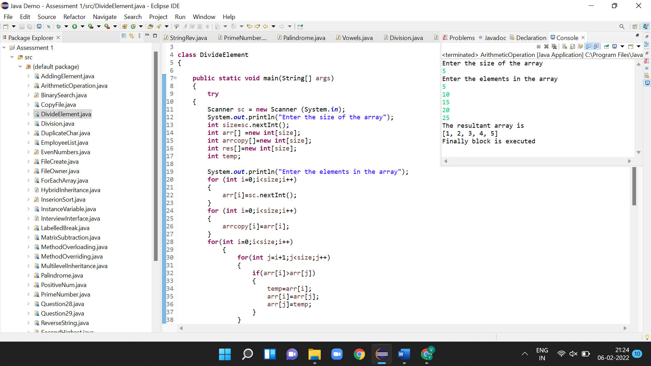

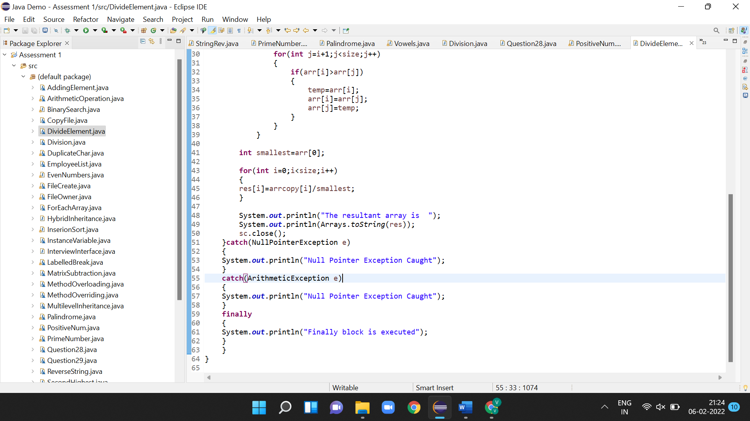

**17.Write a java program to implement a constructor of the class, to print the instance variables value with respect to different objects.**

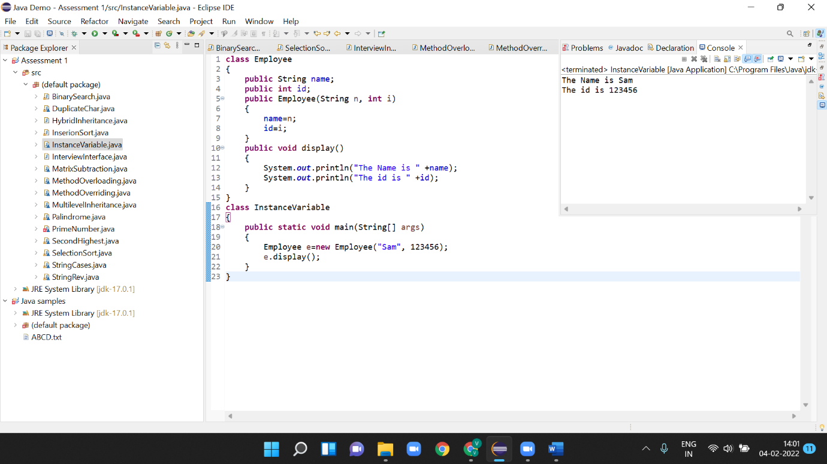

**18.Write a java program to create a File at a particular location and to write to that particular file a String data which is taken as input from the user.**

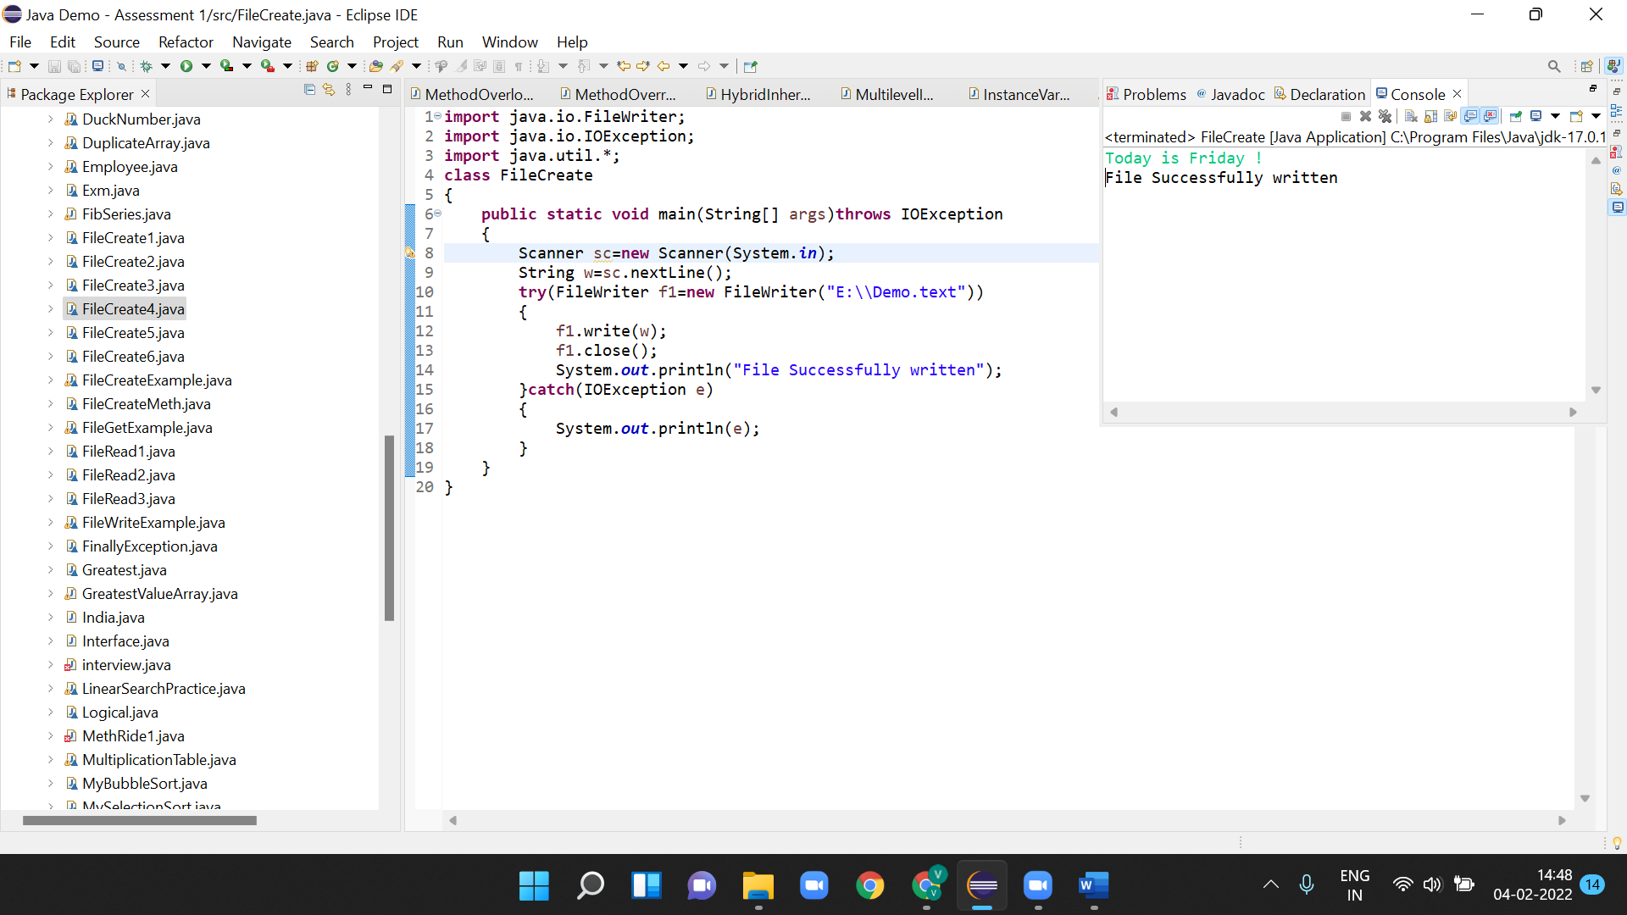

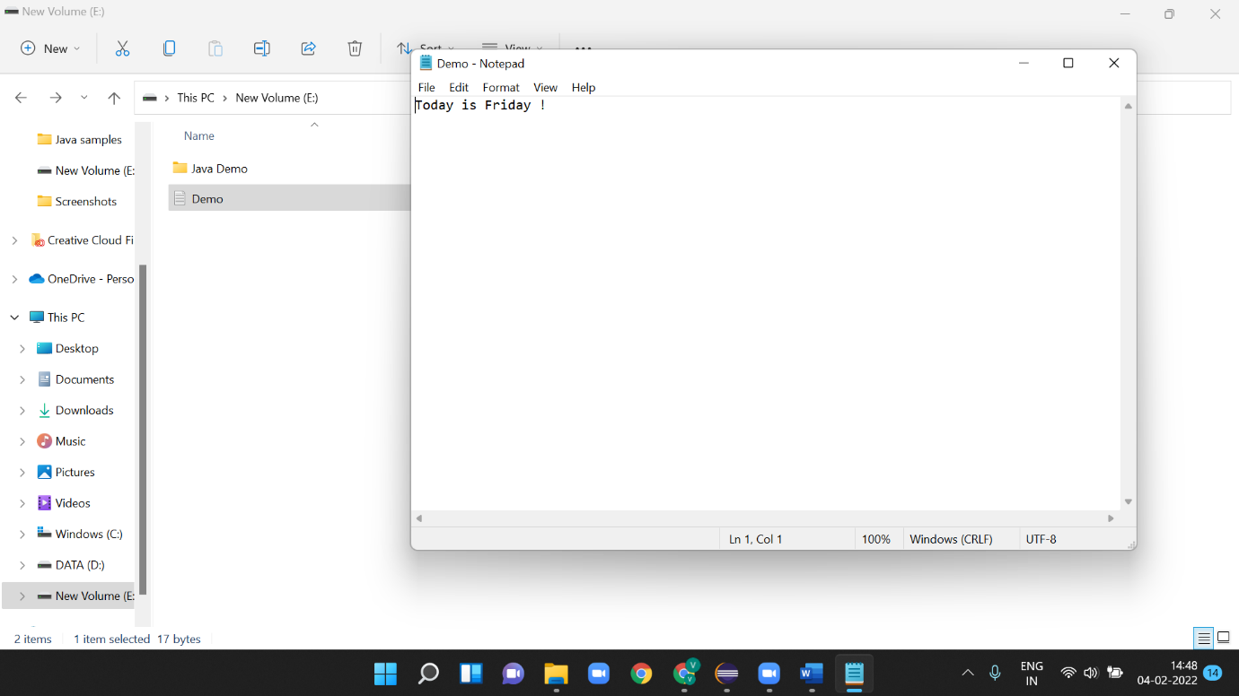

**19.Write a program to read a file from a particular location and determine the number of vowels in that file.**

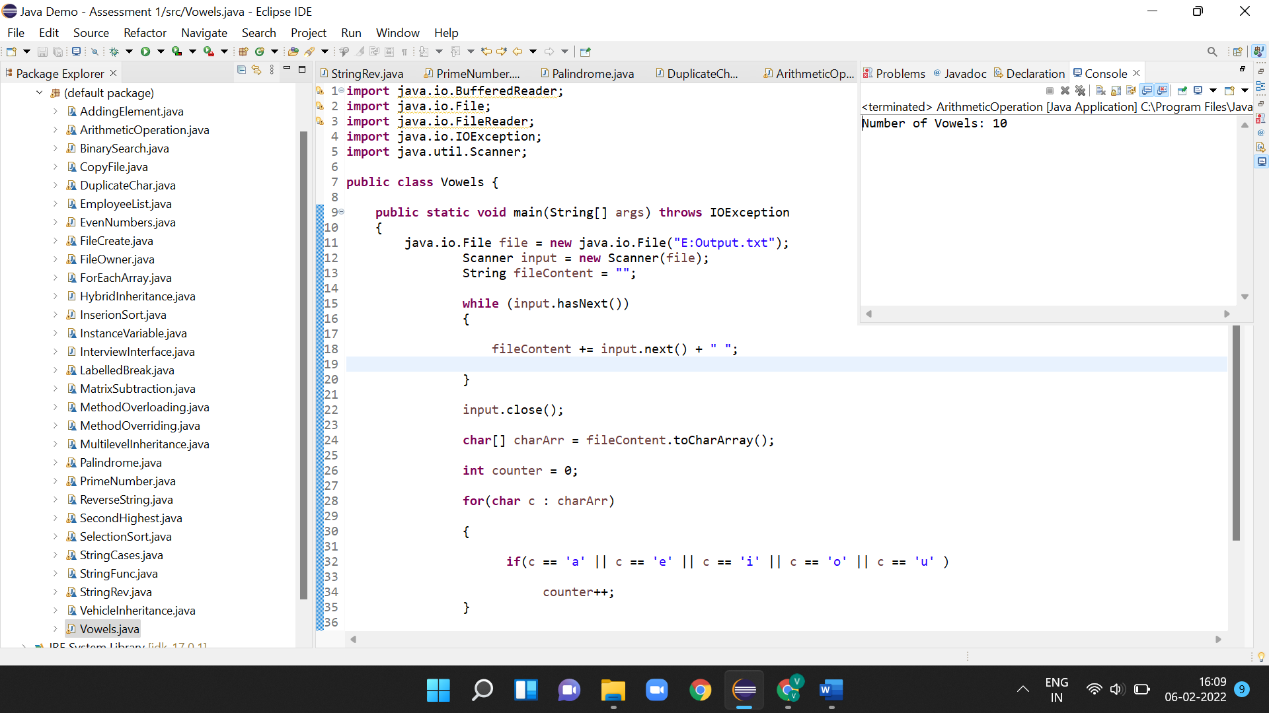

**20.Write a program to take input of two numbers from the user. Now perform the particular arithmetic operation specified by the user and display the result.**

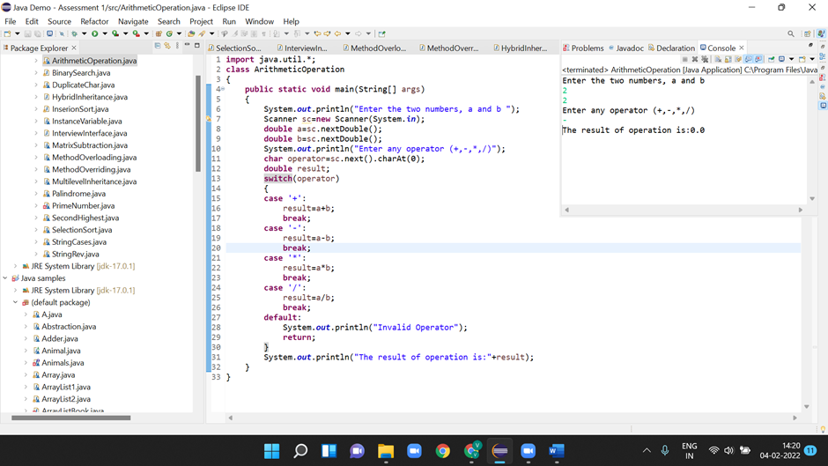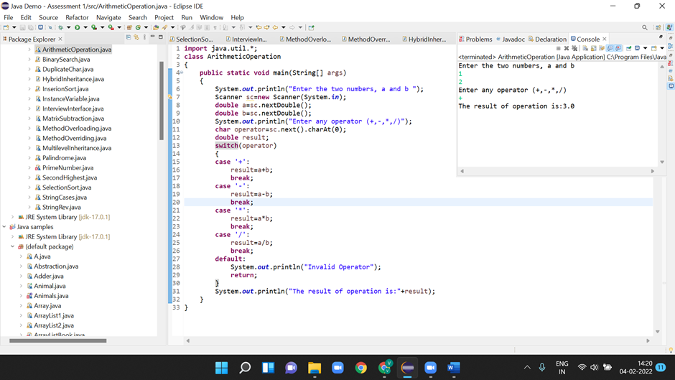

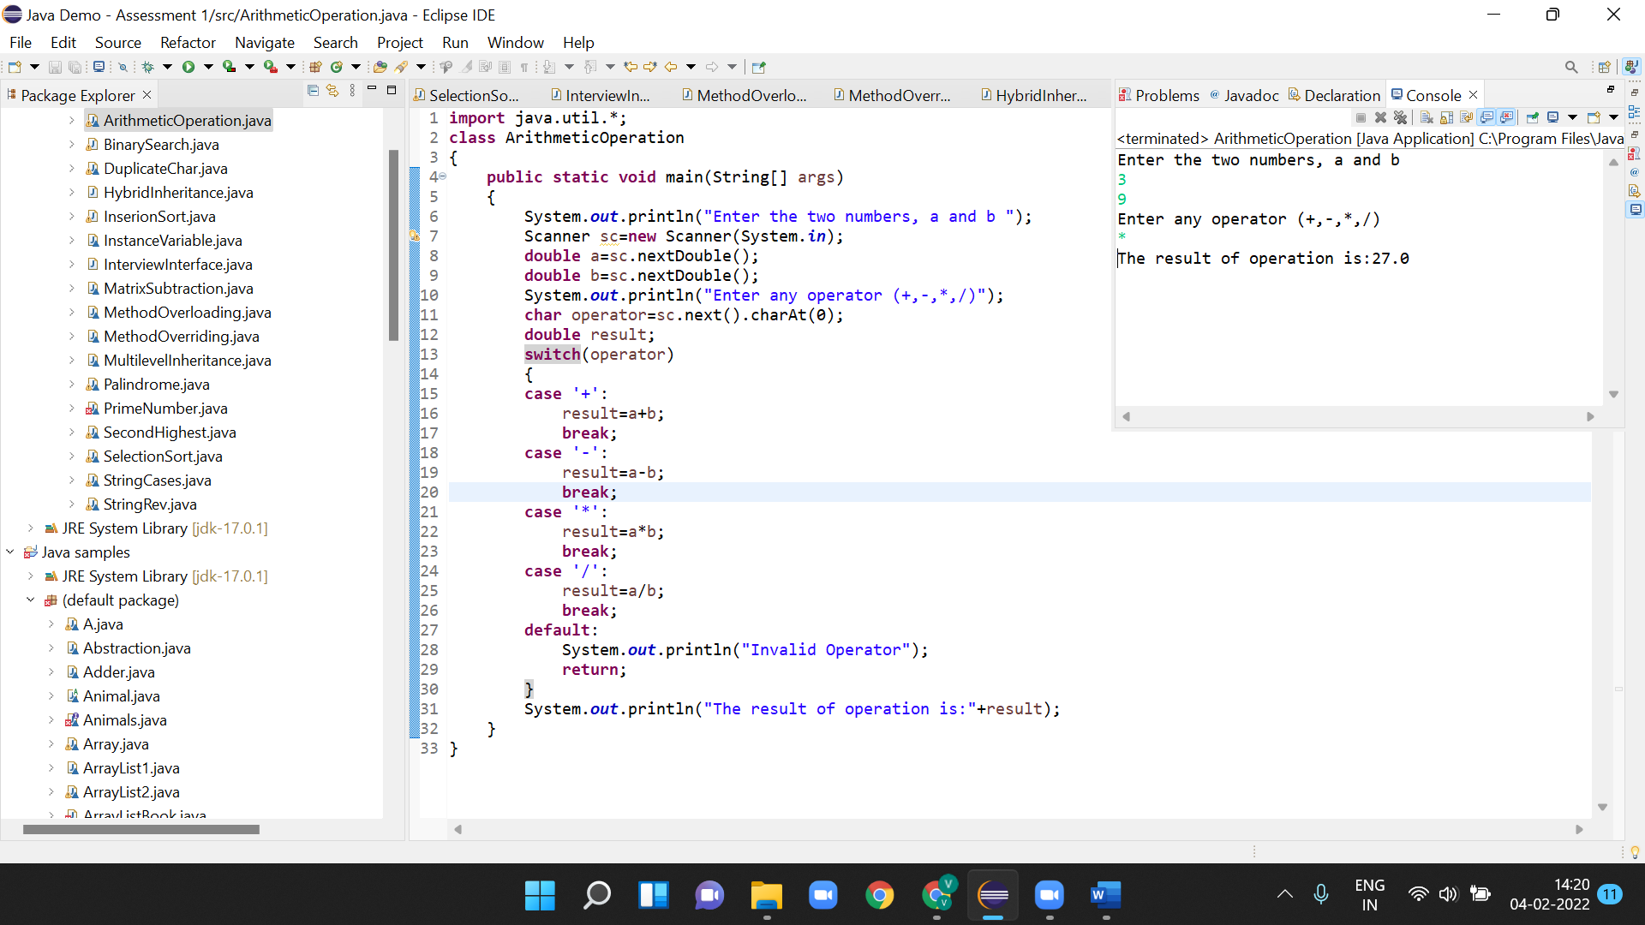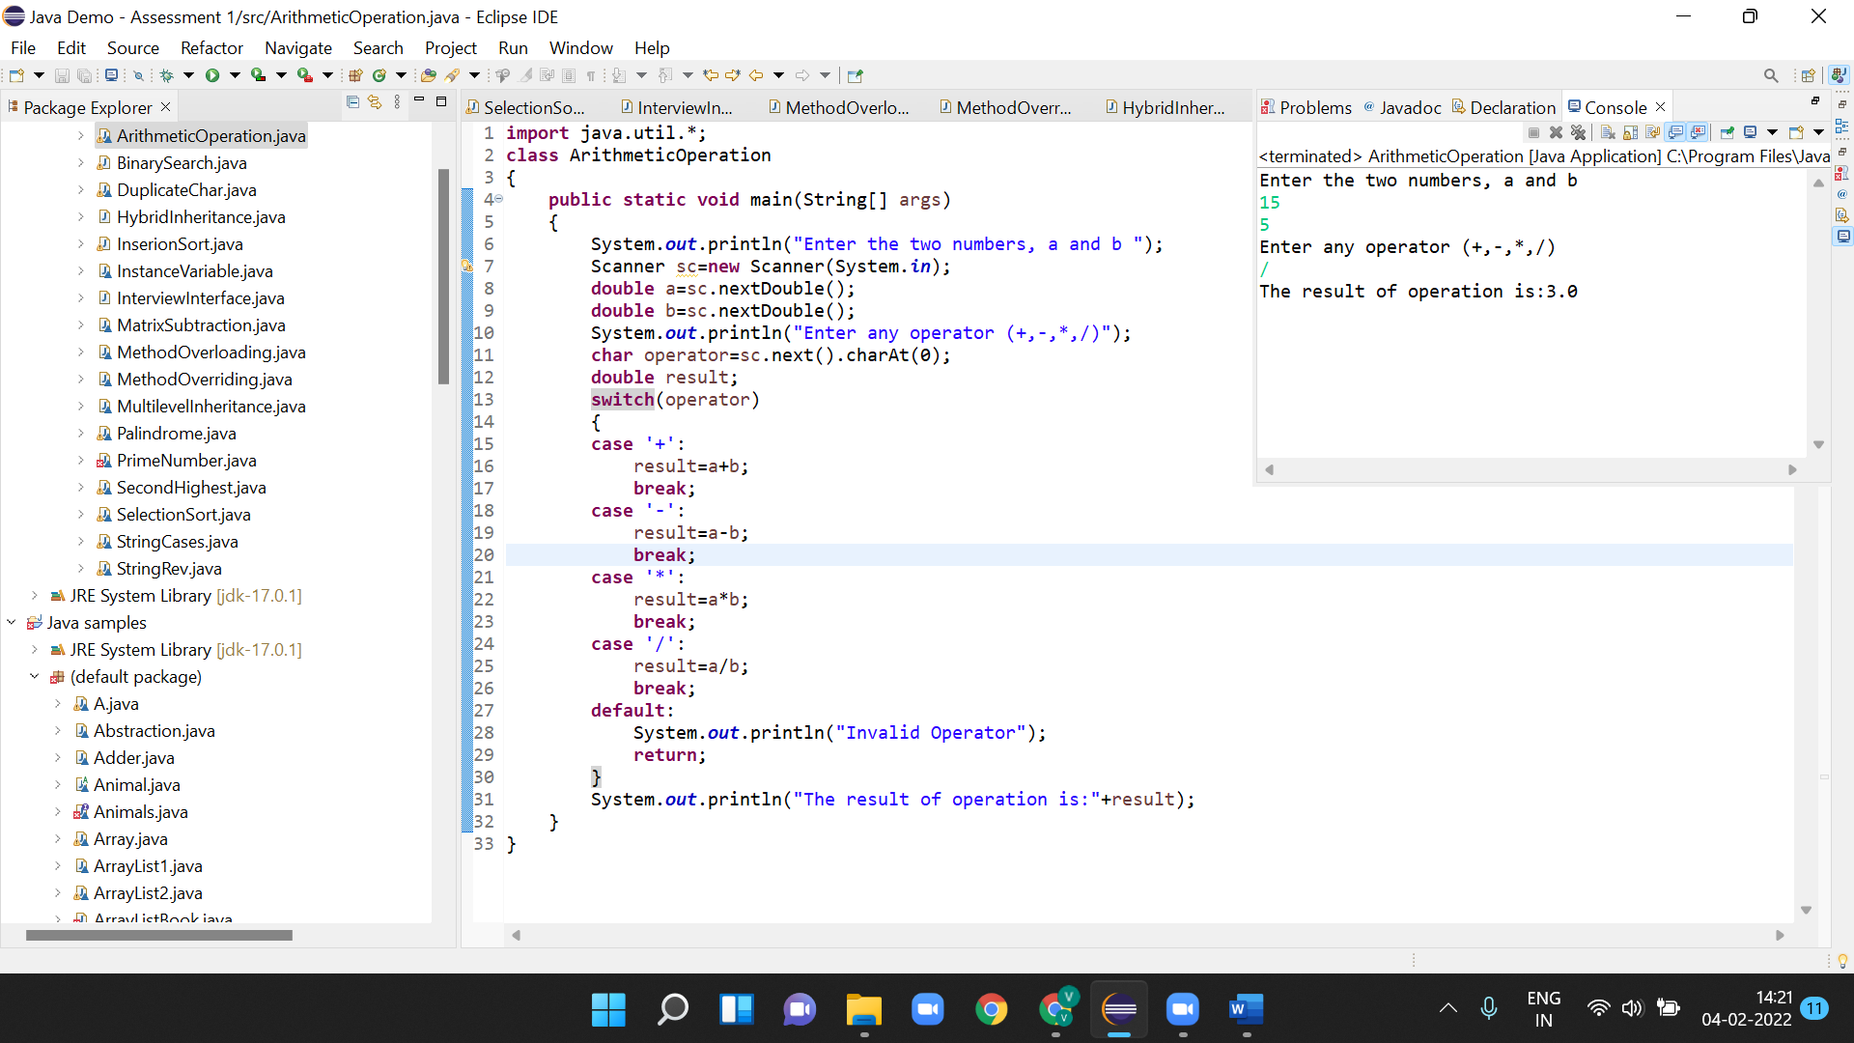

**21.Create an array of 10 elements and print them using the for each loop**

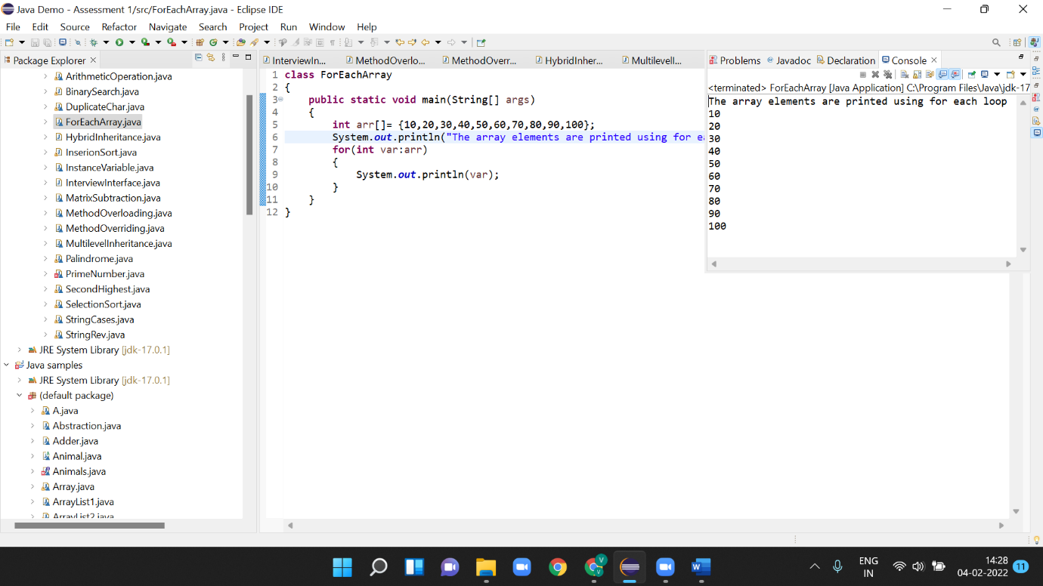

**22. Take the number input from the console and add all the positive numbers. (Not to consider the negative number if entered)**

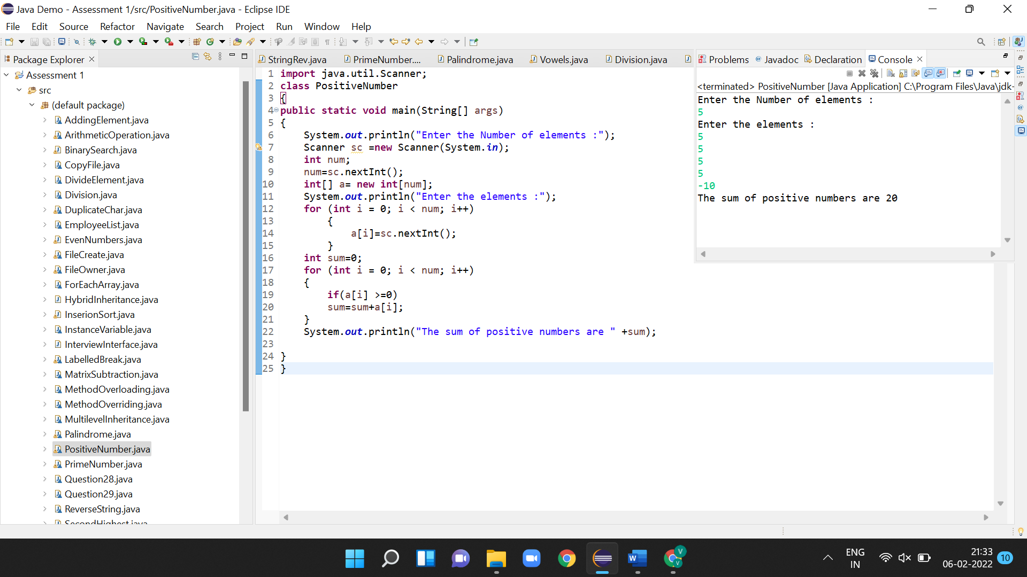

**23.Create a labelled break and write a simple logic and execute the program.**

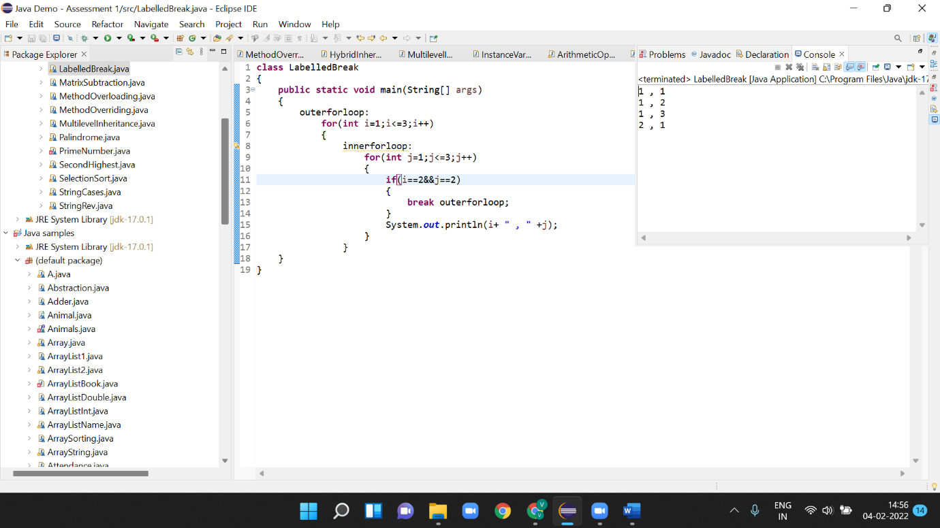

**24.Do the addition of around 10 even numbers, but use the continue statement in the logic.**

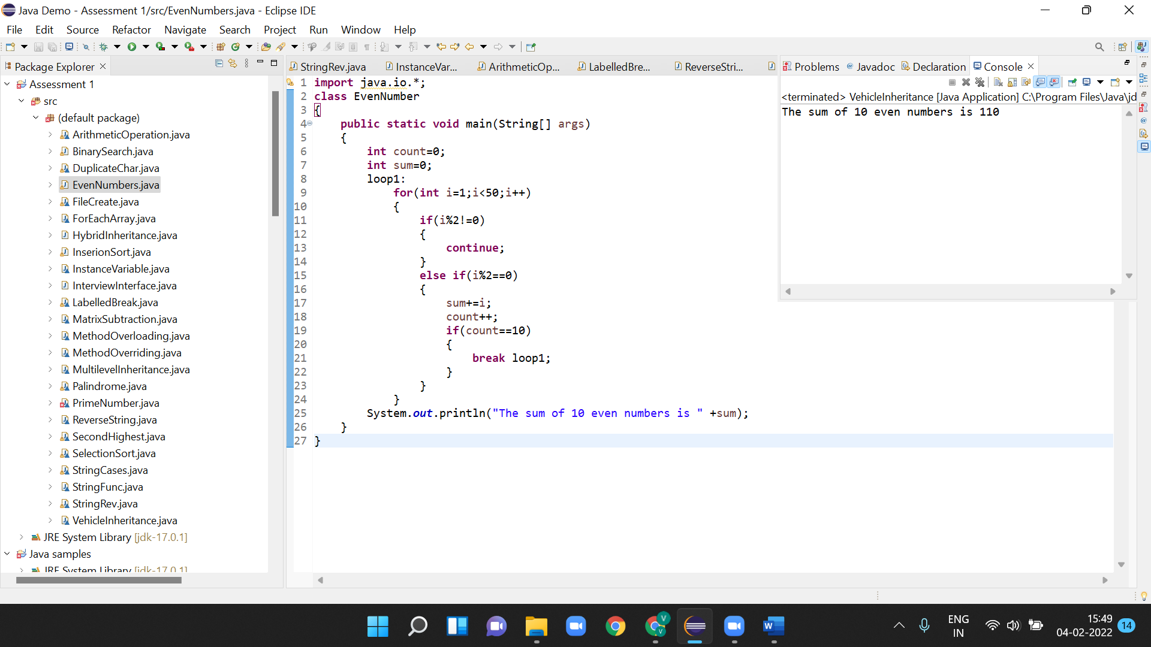

**25.Write a program to reverse the String (use char [] or String built in method)**

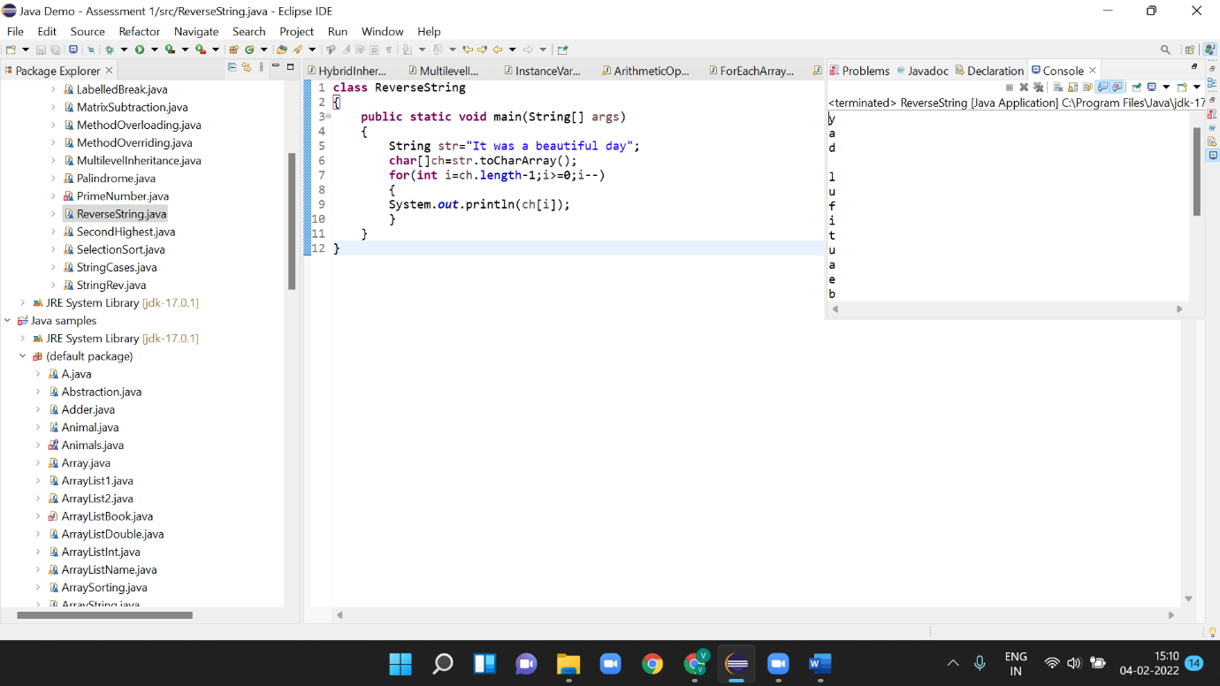

**26.Write programs to depict the usage of contains (), length (), replace (), concat (), equals ()**

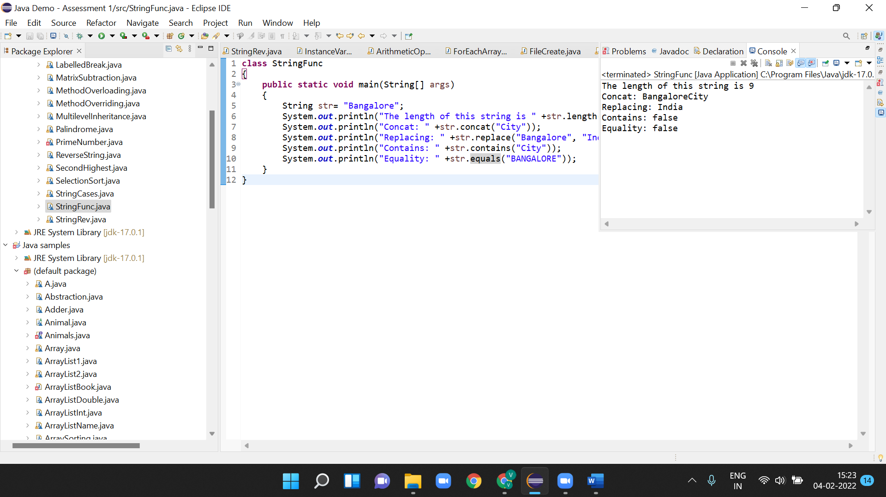

**27.Create an inheritance class. (Super class as Vehicle and 2 subclasses Car and Bike and inherit the Vehicle class methods)**

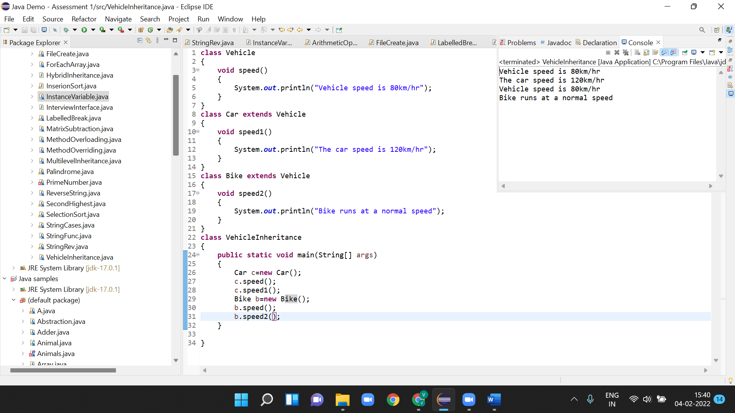

**28.Depict programmatically the Method overloading and Method overriding concepts**

**Method Overloading**

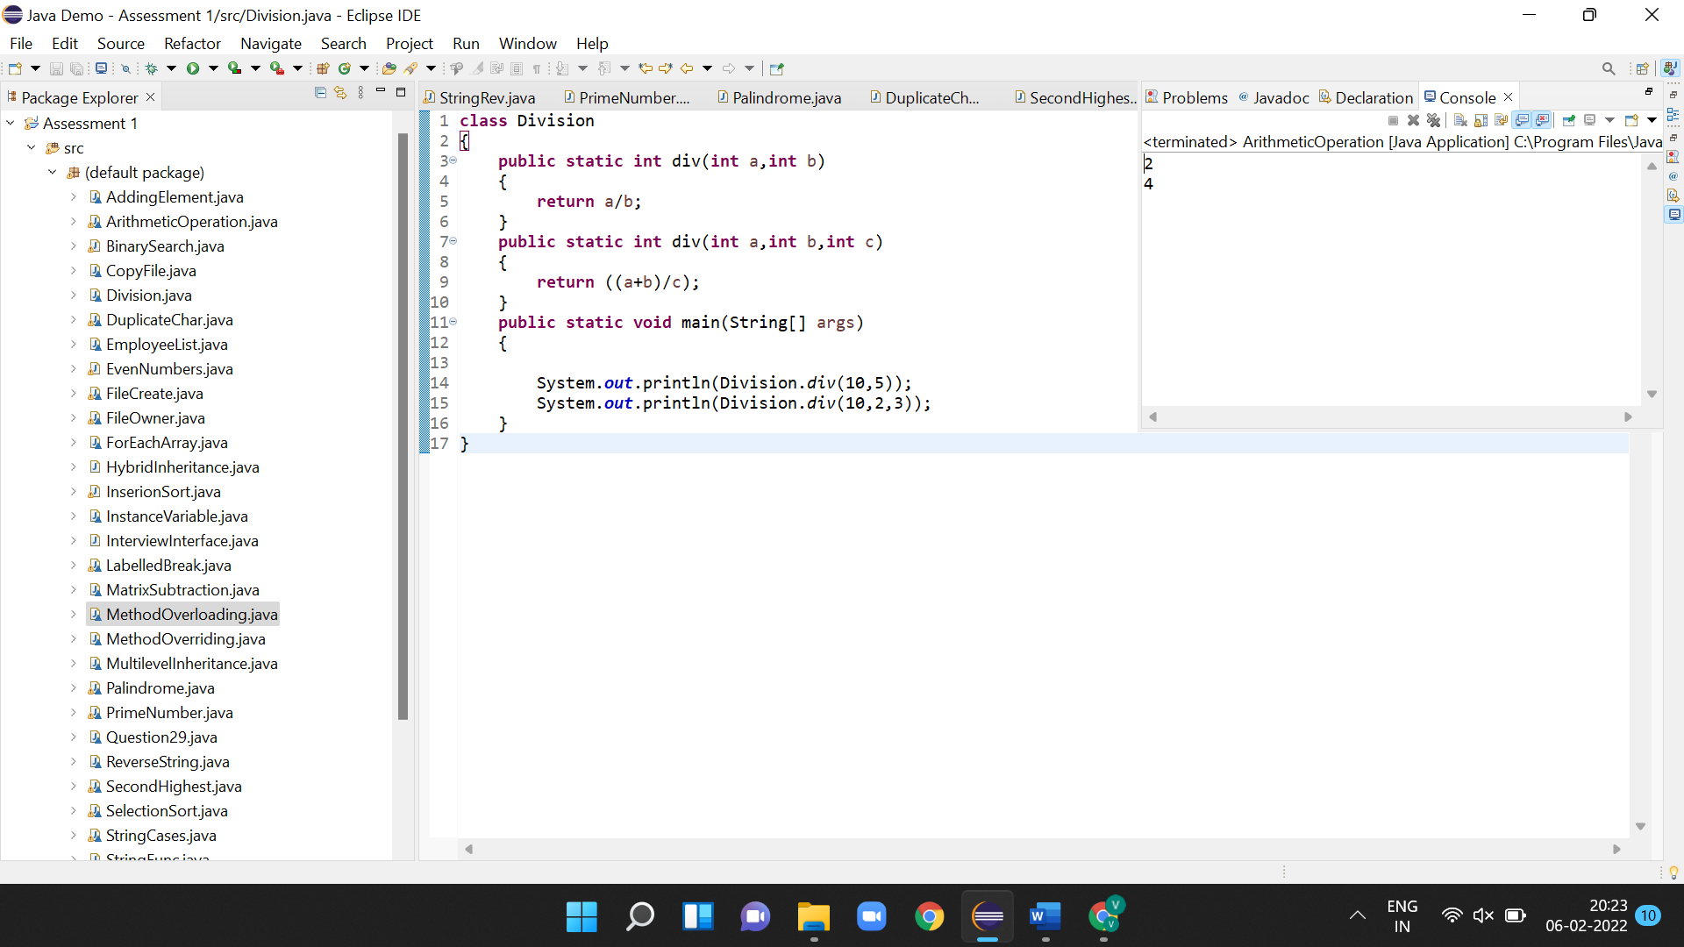

**Method Overriding**

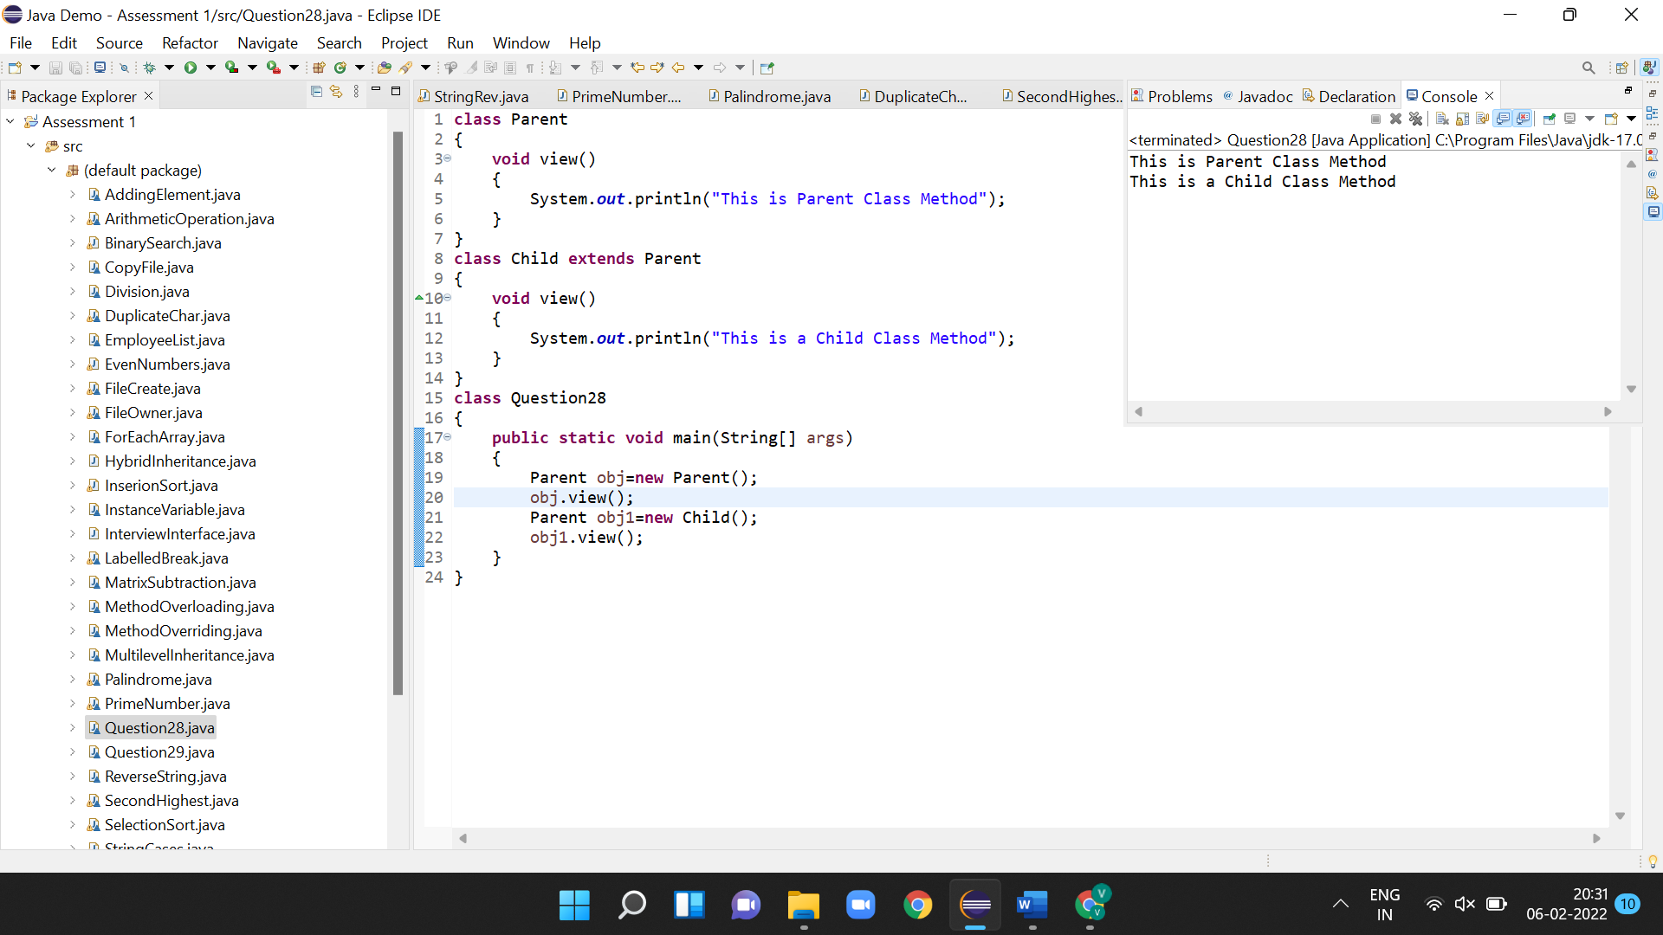

**29.Create an abstract class and extend that class and try to create the object of the abstract class in a program and execute.**

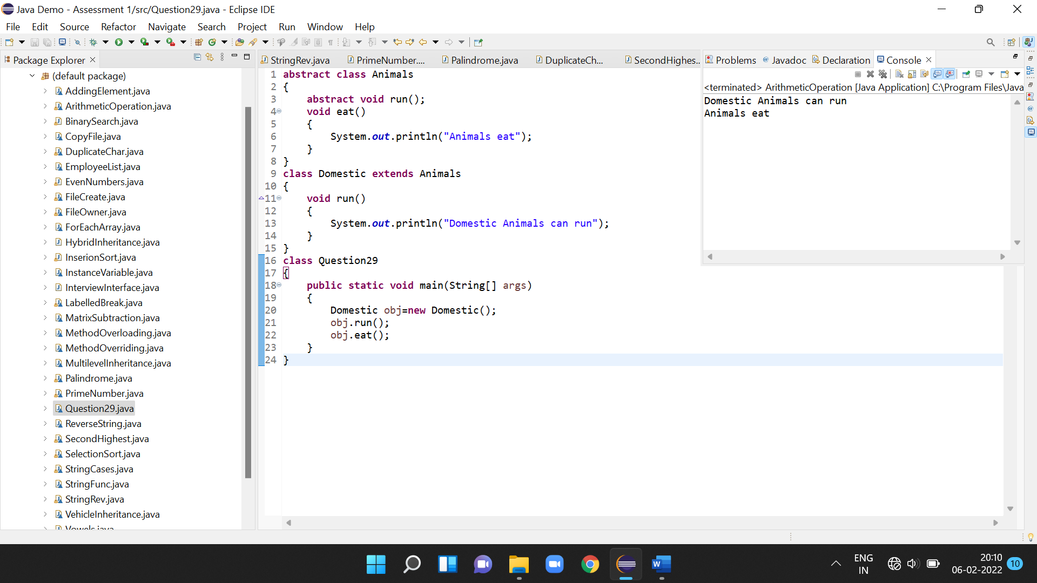

**30.Write a java program to write the data into a file and read back using FileOutputStream/FileInputStream and also try the same using the BufferedReader and BufferedWriter**

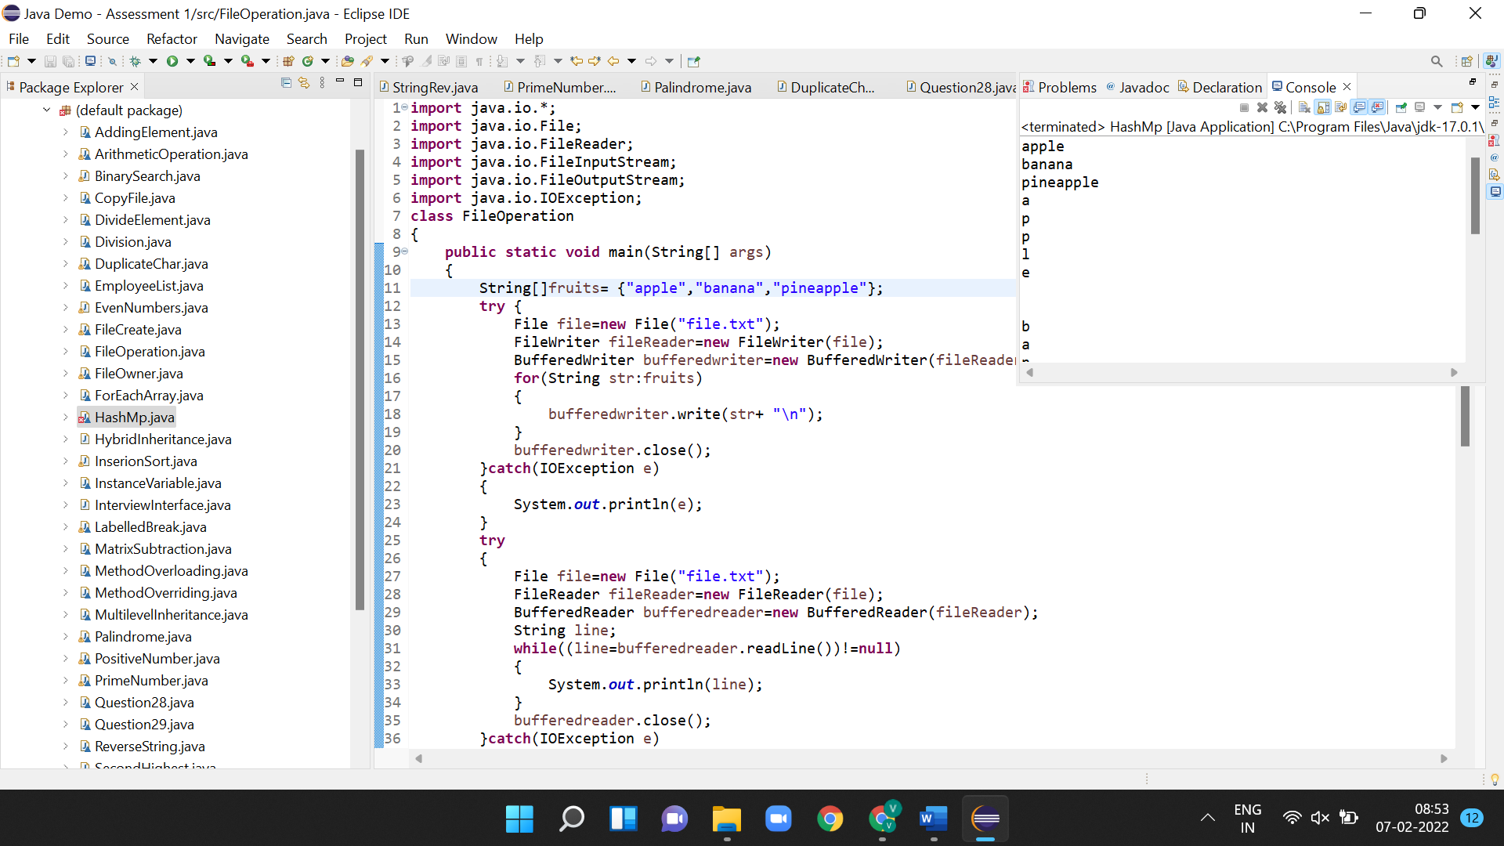

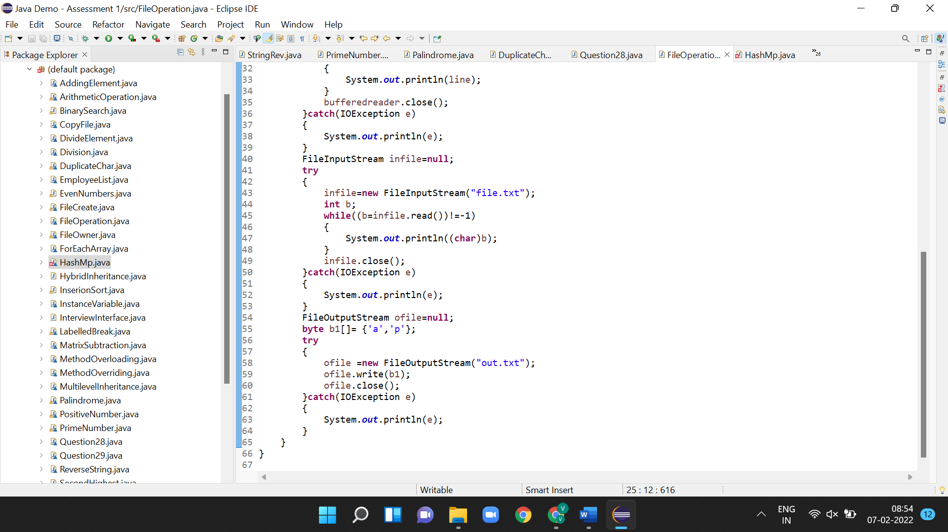

1. **Write a java program to check the file owner details.**

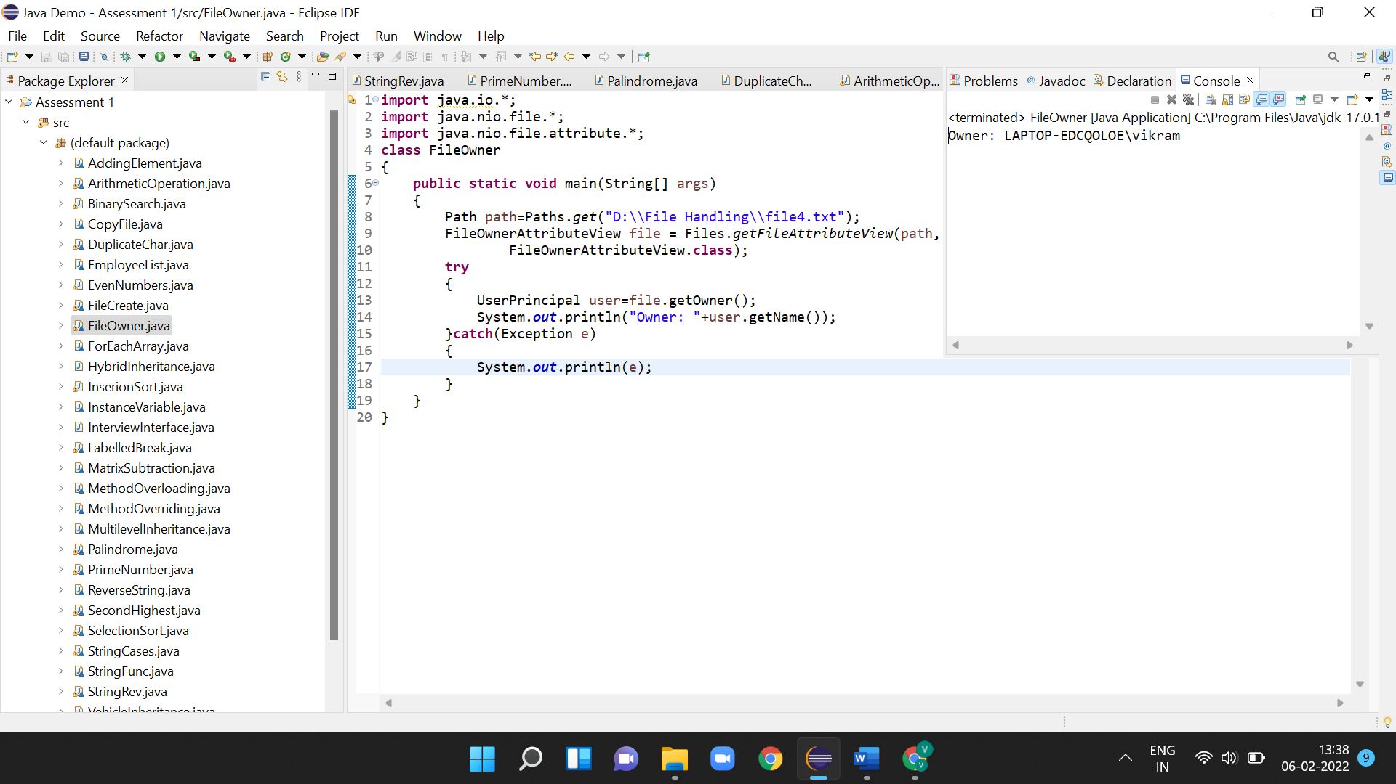

1. **Write a java program to copy data from one file to another file.**

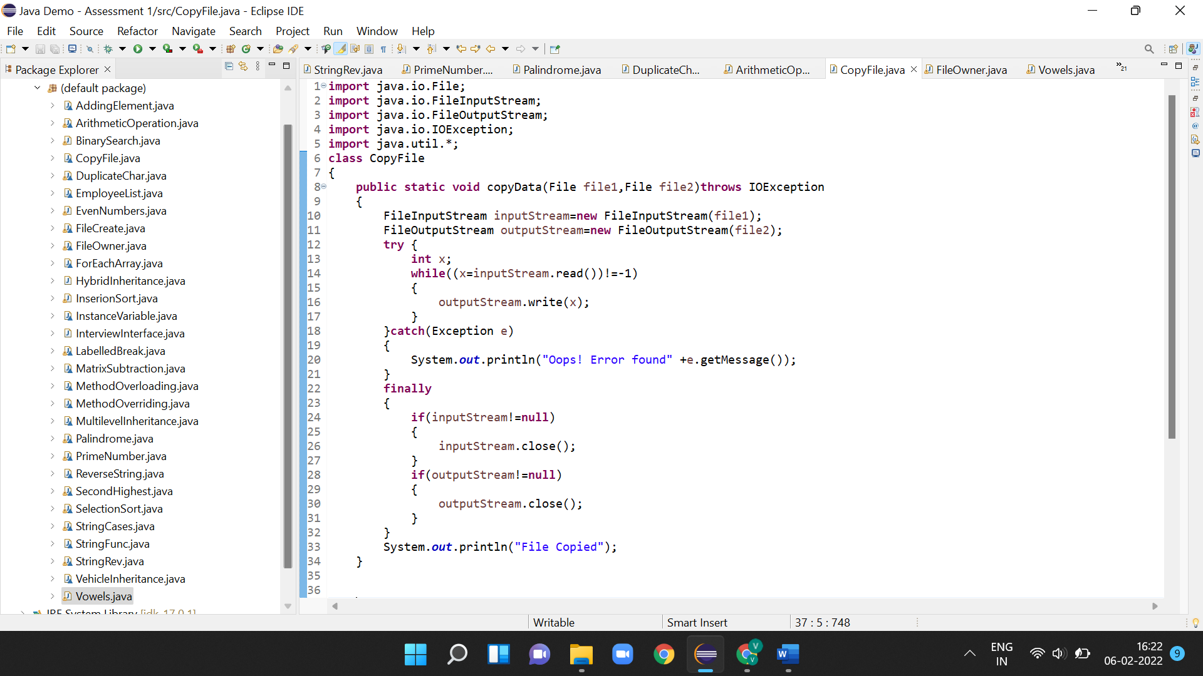

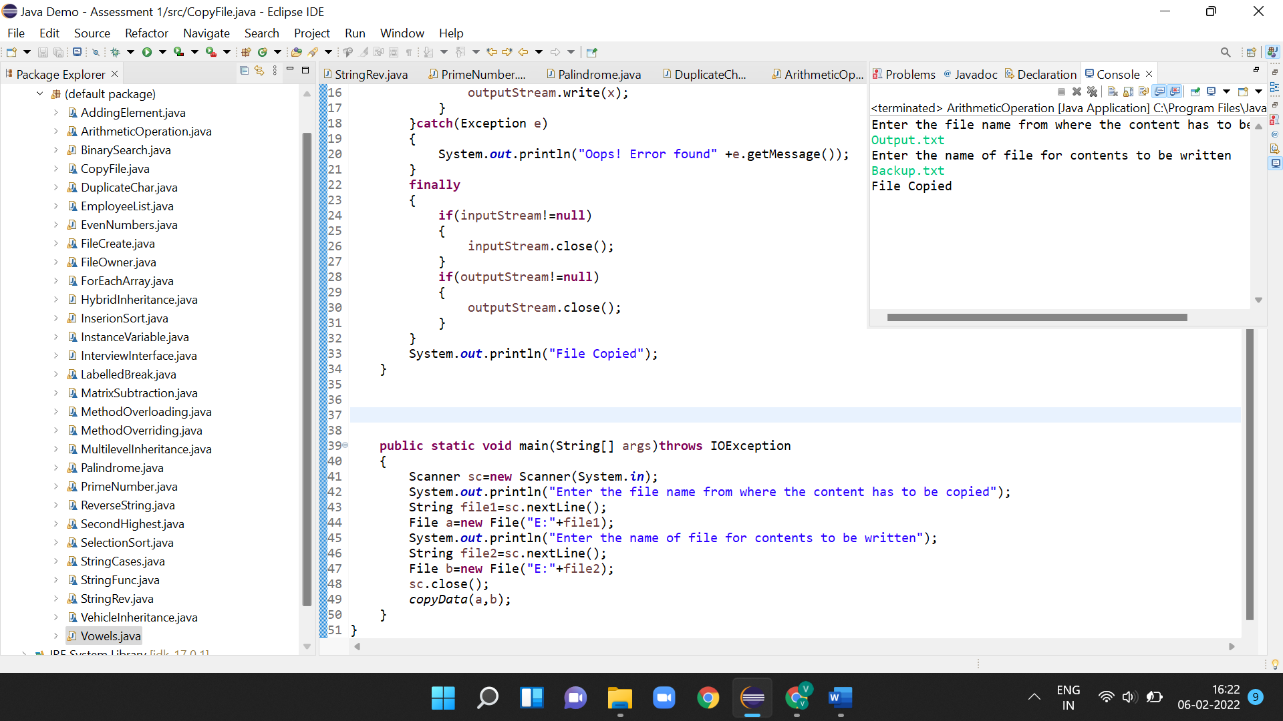

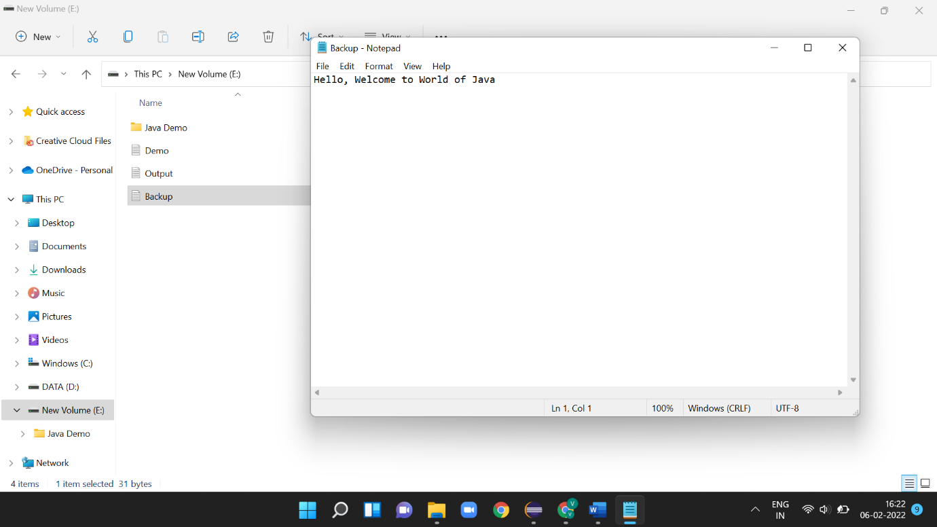

1. **How to add an element at a specific position in an ArrayList (create using <>)**

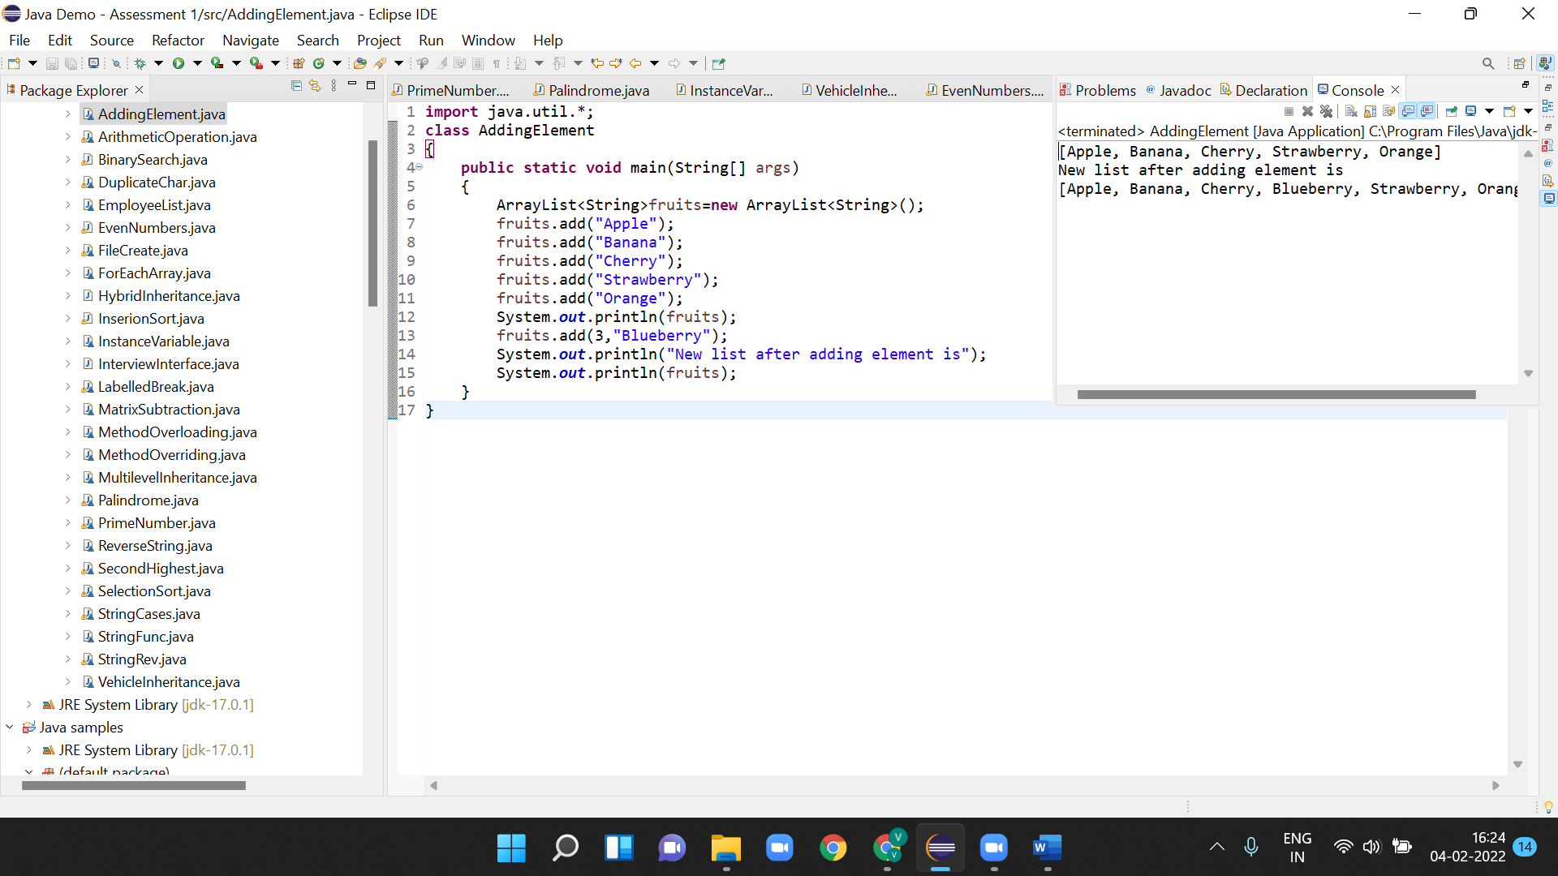

**34.Create an array of employee objects and iterate through it and remove the object at the 2nd position.**

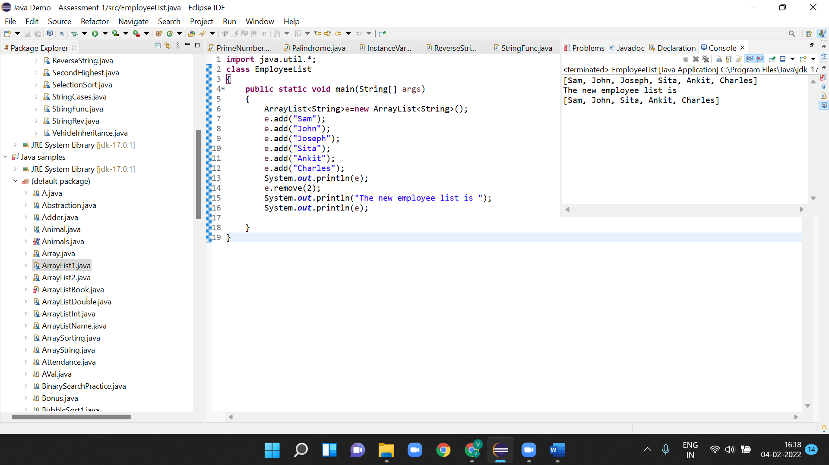

**35.Create a HashMap type and display the elements using the keyset ()**

